STANDARD PROCUREMENT DOCUMENT
Standard Bidding Document for Procurement of Goods
in Projects with Financing from KfW
For use in single stage single envelope international competitive bidding procedures
Version: January 2019

Preface
This Standard Bidding Document (“SBD”) for Procurement of Goods has been prepared by KfW Development Bank (“KfW”) and is based on the harmonized Master Procurement Document “Standard Bidding Documents for Procurement of Goods and User’s Guide” developed by the participating Multilateral Development Banks and International Financing Institutions, which represents the best practices of these institutions.
Project Executing Agencies (referred to hereafter as “Purchasers”) may use this SBD, subject to the nature of the goods, in the procurement of goods, financed in whole or in part by KfW in single stage International Competitive Bidding (ICB) procedures with qualification for goods’ contracts, but with KfW’s prior approval only (standard is the single stage two envelope SBD).
The requirements included herein have been extended to include environmental and social and health and safety requirements (ESHS). These requirements need to be adopted to reflect the ESHS impacts and risks of the implementation of the particular goods contract.
This SBD is to be used for the selection of Bidders in single stage International Competitive Bidding procedures with qualification as described in Section 2 of the KfW Guidelines for Procurement of Goods, Works and Associated Services in Financial Cooperation with Partner Countries (“Guidelines”) and, where applicable, in National Competitive Bidding procedures. Purchasers should seek advice from local competent sources to ascertain its comprehensiveness as well as its suitability in terms of the applicable law. KfW will not be liable for the use of this document by Purchasers in part or full.
These Bidding Documents for Procurement of Goods assume that no prequalification has taken place before bidding.
The simplified single stage single envelope procedure requires that the Bidders’ qualifications be evaluated as first step together with the actual Bids. The procedure involves the use of the single envelope system whereby the Qualification Documents and the Bids are placed in one envelope by the Bidders. There will be one public bid opening session.
[The italicized text in square brackets] is notes to the Purchaser, providing guidance to the Purchaser in preparing a specific bidding document. Notes to the Purchaser shall be deleted from the document before it is issued to Bidders; however, similar text containing instructions for Bidders shall remain.

Feedback to or questions about this document should be in writing to the following address:
FZ-Vergabemanagement@kfw.de

Invitation for Bids
As bids for procurement of goods are generally invited openly from suppliers without using a prequalification procedure, the Invitation for Bids shall be issued directly to the public as a specific procurement notice as
- An advertisement in GTAI (German Trade & Invest); website www.gtai.de
- An advertisement in at least one newspaper of general circulation in the Purchaser’s country (or in the official gazette, or in an electronic portal with free access)
The Invitation for Bids provides information that enables potential bidders to decide whether to participate, including a summary description of the goods and related services; optionally the Invitation for Bids may in addition indicate any important bid evaluation criteria or qualification requirement (for example, a requirement for a minimum level of experience in similar contracts).

Yemen
Integrated Health Resilience Program (IHRP),
Project no. 47862
BMZ no.202167088
ICB No.YAM 23-11
KfW Procurement Number: 510538

The Yamaan Foundation for Health &Social Development has received financing from KfW toward the cost of the Integrated Health Resilience Program (IHRP) and intends to apply part of the proceeds toward payments under the contract(s) for Contraceptives (Oral pills, DMPA injectable & syringes and intrauterine devices (IUDs)).
The Yamaan Foundation for Health & Social Development now invites sealed Bids from eligible Bidders for
1 - Around 3,500,000---- cycles of oral hormonal contraceptives pills combined COC (21 sugar-coted tablets Ethinyl estradiol + Levonorgestrel tablets, 30mcg + 150mcg and 7 sugar-coated tablets containing 75mg Ferrous Fumarate.
2 - Around 1,900,000 cycles of oral hormonal contraceptives, progesterone-only pills POP (28 sugar coted tablets Levonorgestrel 30 mcg).
3 - Around 900,000- vials of Depot Medroxy Progesterone Acetate Injection (DMPA) 150mg/1ml with sterile single-use auto-destruct syringe.
4 - Around 140,000 units of Intrauterine Contraceptive Device (IUD) TCu380A.
Each of the above items must be supplied in Yamaan Foundation’s own label branding (PROTEC) and to be delivered FOB supplier’s country Incoterms 2020, Yemen over a period of 36 months and three shipments.
Bidding will be conducted by means of the International Competitive Bidding procedure with qualification as specified in KfW’s Procurement Guidelines (“KfW Guidelines”). https://www.kfw-entwicklungsbank.de/PDF/Download-Center/PDF-Dokumente-Richtlinien/FZ-Vergaberichtlinien-V-2021-EN.pdf Interested eligible Bidders may obtain further information from Yamaan Foundation, Maha Alnajjar, email: maha.alnajjar@yamaan.org
All bids must be in English, the Bidder shall submit two copies of the technical and financial offer to Yamaan Foundation as well as upload an electronic version to the Exficon platform https://exficon.de/tad/e-procurement/.

In addition, bidders must send 1) 10 sample units (fully packed) of each lot of goods to Yamaan Foundation and 2) 10 sample units (fully packed) to MSI Reproductive Choices. Full instructions are included in the tender document.

Bids must be delivered to the address indicated in the clause ITB 22.1 of the bidding document on or before Tuesday 19^{h} Dec, 2023, 17.00 GMT. Late Bids will be rejected.
Bids will be opened in a public online session in the presence of the Bidders’ designated representatives.

Timeline
Event | Date and Time
Tender launch | Friday 10th November 2023
Request for clarification deadline | Monday 4th December 2023
Clarifications sent out to interested bidders | Thursday 7th December 2023
Deadline for bid submission | Tuesday 19th December 2023
Opening bids | Thursday 21st December 2023

German Financial Cooperation with Yemen

Integrated Health Resilience Program ( IHRP) -
BMZ-no. 202167088, Project no. 47862

Bidding Documents

for

Procurement of: Contraceptives (Oral pills, DMPA injectable & syringes and intrauterine devices (IUDs))

Purchaser: Yamaan Foundation for Health & Social Development
Address: Al-Mansoura Area,90 Street,
Alsafina Round, Al-Qadi Trade Center, Office No.701
Aden Yemen
P.O. Box: 7335

ICB No. YAM 23-11

KfW Procurement Number: 510538

Table of Contents

PART 1 – Bidding Procedures 8

Section I. Instructions to Bidders 9

Section II. Bid Data Sheet (BDS) 31

Section III. Qualification and Evaluation Criteria 35

Section IV. Bidding Forms 45

Section V. Eligibility Criteria 63

Section VI. KfW Policy – Sanctionable Practice – Social and Environmental Responsibility 65

PART 2 – Supply Requirements 67

Section VII. Schedule of Requirements 68

PART 1 – Bidding Procedures

Section I. Instructions to Bidders
Table of Clauses

A. General 10

1. Scope of Bid 10

2. Source of Funds 10

3. Corrupt and Fraudulent Practices 10

4. Eligible Bidders 10

5. Eligible Goods and Related Services 12

B. Contents of Bidding Documents 12

6. Sections of Bidding Documents 12

7. Clarification of Bidding Documents 13

8. Amendment of Bidding Document 13

C. Preparation of Bids 14

9. Cost of Bidding 14

10. Language of Bid 14

11. Documents Comprising the Bid 14

12. Declaration of Undertaking, Qualification Forms, and Bid Submission Form, Bidding Forms, Price Schedules 15

13. Alternative Bids 15

14. Bid Prices and Discounts 15

15. Currencies of Bid and Payment 17

16. Documents Establishing the Eligibility and Conformity of the Goods and Related Services 17

17. Documents Establishing the Eligibility and Qualifications of the Bidder 18

18. Period of Validity of Bids 18

19. Bid Security 19

20. Format and Signing of Bid 21

D. Submission and Opening of Bids 21

21. Sealing and Marking of Bids 21

22. Deadline for Submission of Bids 22

23. Late Bids 22

24. Withdrawal, Substitution, and Modification of Bids 22

25. Bid Opening 23

E. Evaluation and Comparison of Bids 25

26. Confidentiality 25

27. Qualification of the Bidder 25

28. Clarification of Bids 25

29. Deviations, Reservations, and Omissions 26

30. Determination of Respon-siveness 26

31. Non-conformities, Errors and Omissions 26

32. Correction of Arithmetical Errors 27

33. Conversion to Single Currency 27

34. Margin of Preference 27

35. Evaluation of Bids 27

36. Comparison of Bids 29

37. Purchaser’s Right to Accept Any Bid, and to Reject Any or All Bids 29

F. Award of Contract 29

38. Award Criteria 29

39. Purchaser’s Right to Vary Quantities at Time of Award 29

40. Notification of Award 29

41. Signing of Contract 30

42. Performance Security 30

Section I. Instructions to Bidders
 | - General
1. Scope of Bid | - In connection with the Invitation for Bids, specified in the Bid Data Sheet (BDS), the Purchaser, as specified in the BDS, issues these Bidding Documents for the Procurement of Goods and Related Services incidental thereto as specified in Section VII, Schedule of Requirements. The name, identification and number of lots (contracts) of this International Competitive Bidding (ICB) are specified in the BDS.  - Throughout these Bidding Documents:  - The term “in writing” means communicated in written form (e.g. by mail, e-mail, fax, telex) with proof of receipt;  - If the context so requires, “singular” means “plural” and vice versa; and  - “Day” means calendar day.
2. Source of Funds | - The Purchaser specified in the BDS has applied for or received financing (hereinafter called “funds”) from the KfW Entwicklungsbank (hereinafter called “the KfW”), toward the project named in the BDS. The Purchaser intends to apply a portion of the funds to eligible payments under the contract for which these Bidding Documents are issued.
3. Corrupt and Fraudulent Practices | 3.1 KfW requires compliance with its policy in regard to corrupt and fraudulent practices as set forth in Section VI.  3.2 In further pursuance of this policy, Bidders shall permit and shall cause its agents to provide information and permit KfW or an agent appointed by KfW to inspect on site all accounts, records and other documents relating to bid submission and contract performance (in the case of award), and to have them audited by auditors or agents appointed by KfW.
4. Eligible Bidders | - A Bidder may be a firm that is a private entity, a state-owned entity- subject to ITB 4.3 - or any combination of such entities in the form of a joint venture (“JV”) under an existing JV Agreement or with the intent to enter into such an agreement supported by a letter of intent to execute a JV Agreement, in accordance with ITB 11.2. In the case of a JV, all members shall be jointly and severally liable for the execution of the Contract in accordance with the Contract terms. The Bidder shall nominate an authorised representative who shall have the authority to conduct all business for and on behalf of Bidder and any and all its members, if the Bidder is a JV, during bidding and contract execution (in the event the Bidder is awarded the Contract). Unless specified in the BDS, there is no limit on the number of members in a JV.  - A Bidder shall not have a conflict of interest. Any Bidder found to have a conflict of interest shall be disqualified. A Bidder may be considered to have a conflict of interest for the purpose of this bidding process, if the Bidder:  - Directly or indirectly controls, is controlled by or is under common control with another Bidder; or  - Receives or has received any direct or indirect subsidy from another Bidder; or  - Has the same legal representative as another Bidder; or  - Has a relationship with another Bidder, directly or through common third parties, that puts it in a position to influence the bid of another Bidder, or influence the decisions of the Purchaser regarding this bidding process; or  - Participates in more than one bid in this bidding process, both as an individual firm and as a JV member. Participation by a Bidder in more than one Bid will result in the disqualification of all Bids in which such Bidder is involved. However, this does not limit the inclusion of the same subcontractor in more than one bid; or  - Any of its affiliates participated as a consultant in the preparation of the design or technical specifications of the goods that are the subject of the bid; or  - Any of its affiliates has been hired (or is proposed to be hired) by the Purchaser for the Contract implementation; or  - Has a close business or family relationship with a professional staff of the Purchaser (or of the project implementing agency, or of a recipient of a part of the funds) who: (i) are directly or indirectly involved in the preparation of the bidding documents or specifications of the contract, and/or the bid evaluation process of such contract; or (ii) would be involved in the implementation or supervision of such contract unless the conflict stemming from such relationship has been resolved in a manner acceptable to the KfW throughout the procurement process and execution of the contract.  - The KfW’s eligibility criteria to bid are described in Section V, Eligibility criteria.  - A Bidder shall not be under suspension from bidding by the Purchaser as the result of the execution of a Bid-Securing Declaration.  - This bidding is open only to eligible Bidders, who will be subject to qualification.  - A Bidder shall provide such evidence of eligibility satisfactory to the Purchaser, as specified in ITB 17.1 or as the Purchaser shall reasonably request.
5. Eligible Goods and Related Services | - All the Goods and Related Services to be supplied under the Contract and financed by the KfW shall have their origin in any country in accordance with Section V, Eligibility Criteria.  - For purposes of this Clause, the term “goods” includes commodities, raw material, machinery, equipment, and industrial plants; and “related services” includes services such as insurance, installation, training, and initial maintenance.  - The term “origin” means the country where the goods have been mined, grown, cultivated, produced, manufactured or processed; or, through manufacture, processing, or assembly, another commercially recognized article results that differs substantially in its basic characteristics from its components.
 | - Contents of Bidding Documents
6. Sections of Bidding Documents | - The Bidding Documents consist of Parts 1, 2, and 3, which include all the Sections indicated below, and should be read in conjunction with any Addenda issued in accordance with ITB 8.  PART 1 - Bidding Procedures  - Section I. Instructions to Bidders (ITB);  - Section II. Bid Data Sheet (BDS);  - Section III. Qualification and Evaluation Criteria;  - Section IV. Bidding Forms;  - Section V. Eligibility Criteria;  - Section VI. KfW Policy - Corrupt and Fraudulent Practices and Social and Environmental Responsibility;
PART 2 - Supply Requirements
- Section VII. Schedule of Requirements;
PART 3 - Contract
- Section VIII. General Conditions of Contract (GC);
- Section IX. Particular Conditions of Contract (PC);
- Section X. Contract Forms.
  - The Invitation for Bids issued by the Purchaser is not part of the Bidding Documents.
  - Unless obtained directly from the Purchaser, the Purchaser is not responsible for the completeness of the Bidding Documents, responses to requests for clarification or Addenda to the Bidding Documents in accordance with ITB 8. In case of any contradiction, documents obtained directly from the Purchaser shall prevail.
  - The Bidder is expected to examine all instructions, forms, terms, and specifications in the Bidding Documents and to furnish with its Bid all information or documentation as is required by the Bidding Documents.
7. Clarification of Bidding Documents | - A Bidder requiring any clarification of the Bidding Documents shall contact the Purchaser in writing at the Purchaser’s address specified in the BDS. The Purchaser will respond in writing to any request for clarification, provided that such request is received no later than 14 (fourteen) days prior to the deadline for submission of bids. The Purchaser shall forward copies of its response to all Bidders who have acquired the Bidding Documents in accordance with ITB 6.3, including a description of the inquiry but without identifying its source. If so specified in the BDS, the Purchaser shall also promptly publish its response at the web page identified in the BDS. Should the clarification result in changes to the essential elements of the Bidding Documents, the Purchaser shall amend the Bidding Documents following the procedure under ITB 8 and ITB 22.2.
8. Amendment of Bidding Document | - At any time prior to the deadline for submission of bids, the Purchaser may amend the Bidding Documents by issuing addenda.  - Any addendum issued shall be part of the Bidding Documents and shall be communicated in writing to all who have obtained the Bidding Documents from the Purchaser in accordance with ITB 6.3. The Purchaser shall also promptly publish the addendum on the Purchaser’s web page in accordance with ITB 7.1.  - To give Bidders reasonable time in which to take an addendum into account in preparing their bids, the Purchaser may, at its discretion, extend the deadline for the submission of bids, pursuant to ITB 22.2.
 | - Preparation of Bids
9. Cost of Bidding | - The Bidder shall bear all costs associated with the preparation and submission of its bid, and the Purchaser shall not be responsible or liable for those costs, regardless of the conduct or outcome of the bidding process.
10. Language of Bid | - The Bid, as well as all correspondence and documents relating to the Bid exchanged by the Bidder and the Purchaser, shall be written in the language specified in the BDS. Supporting documents and printed literature that are part of the Bid may be in another language provided they are accompanied by an accurate translation of the relevant passages into the language specified in the BDS, in which case, for purposes of interpretation of the Bid, such translation shall govern.
11. Documents Comprising the Bid | - The Bid shall comprise the following:  - Qualification  - Bid Submission Form [see also (b)(i) below], in accordance with Section III (1.2) (Table 1);  - Declaration of Undertaking duly signed, in accordance with Section III (1.2) (Table 1);  - Written confirmation authorizing the signatory of the Bid to commit the Bidder, in accordance with ITB 20.2 and Section III (1.2) (Table 1);  - Any other forms and supporting documents required in Section III (1.1) (1.2) (Tables 1 to 5).  - Technical and Financial Bid  - Bid Submission Form and the Bidding Forms in accordance with ITB 12;  - Completed schedules, in accordance with ITB 12 and 14;  - Bid Security, in accordance with ITB 19.1;  - Alternative bids, if permissible, in accordance with ITB 13;  - Documentary evidence in accordance with ITB 17 establishing the Bidder’s qualifications to perform the contract if its Bid is accepted;  - Documentary evidence in accordance with ITB 17 establishing the Bidder’s eligibility to bid;  - Documentary evidence in accordance with ITB 16, that the Goods and Related Services to be supplied by the Bidder are of eligible origin;  - Documentary evidence in accordance with ITB 16 and 30, that the Goods and Related Services conform to the Bidding Documents;  - Any other document required in the BDS.  11.2 In addition to the requirements under ITB 11.1, bids submitted by a JV shall include a copy of the Joint Venture Agreement entered into by all members. Alternatively, a letter of intent to execute a Joint Venture Agreement in the event of a successful bid shall be signed by all members and submitted with the bid, together with a copy of the proposed Agreement.  11.3 The Bidder shall furnish in the Bid Submission Form information on commissions and gratuities, if any, paid or to be paid to agents or any other party relating to this Bid.
12. Declaration of Undertaking, Qualification Forms, and Bid Submission Form, Bidding Forms, Price Schedules | - The Declaration of Undertaking and the Qualification Forms as listed in ITB 11.1(a) shall be prepared using the relevant forms furnished in Section IV, Bidding Forms. The forms must be completed without any alterations to the text, and no substitutes shall be accepted except as provided under ITB 20.4. All blank spaces shall be filled in with the information requested.  - The Bid Submission Form, the Price Schedules, and the Bidding Forms as listed in ITB 11.1(b) shall be prepared using the relevant forms furnished in Section IV, Bidding Forms. The forms must be completed without any alterations to the text, and no substitutes shall be accepted except as provided under ITB 20.4. All blank spaces shall be filled in with the information requested.
13. Alternative Bids | - Unless otherwise specified in the BDS, alternative bids shall not be considered.
14. Bid Prices and Discounts | - The prices and discounts quoted by the Bidder in the Bid Submission Form and in the Price Schedules shall conform to the requirements specified below.  - All lots (contracts) and items must be listed and priced separately in the Price Schedules.  - The price to be quoted in the Bid Submission Form shall be the total price of the bid, excluding any discounts offered.  - The Bidder shall quote any discounts and indicate the methodology for their application in the Bid Submission Form.  - Prices quoted by the Bidder shall be fixed during the Bidder’s performance of the Contract and not subject to variation on any account, unless otherwise specified in the BDS. A bid submitted with an adjustable price quotation shall be treated as nonresponsive and shall be rejected, pursuant to ITB 30. However, if in accordance with the BDS, prices quoted by the Bidder shall be subject to adjustment during the performance of the Contract, a bid submitted with a fixed price quotation shall not be rejected, but the price adjustment shall be treated as zero.  - If so specified in ITB 1.1, bids are being invited for individual lots (contracts) or for any combination of lots (packages). Prices quoted shall correspond to 100 % of the items specified for each lot and to 100% of the quantities specified for each item of a lot. Bidders wishing to offer discounts for the award of more than one Contract shall specify in their bid the price reductions applicable to each package, or alternatively, to individual Contracts within the package. Discounts shall be submitted in accordance with ITB 14.4 provided the bids for all lots (contracts) are opened at the same time.  - The term CIP (Carriage and Insurance Paid to), and other similar terms shall be governed by the rules prescribed in the current edition of Incoterms, published by The International Chamber of Commerce, as specified in the BDS.  - Prices shall be quoted as specified in each Price Schedule included in Section IV, Bidding Forms. The disaggregation of price components is required solely for the purpose of facilitating the comparison of bids by the Purchaser. In quoting prices, the Bidder shall be free to use transportation through carriers registered in any eligible country, in accordance with Section V, Eligibility Criteria. Similarly, the Bidder may obtain insurance services from any eligible country in accordance with Section V, Eligibility Criteria. Prices shall be entered in the following manner:  - For Goods manufactured in the Purchaser’s Country:  - The price of the Goods quoted CIP named place of destination (final destinations), including all customs duties and sales and other taxes already paid or payable on the components and raw material used in the manufacture or assembly of the Goods;  - All related services required in these Bidding Documents; and  - Any Purchaser’s Country sales tax and other taxes which will be payable on the Goods if the contract is awarded to the Bidder.  - For Goods manufactured outside the Purchaser’s Country, to be imported:  - The price of the Goods, quoted CIP named place of destination (port of entry and/or place of customs clearance), in the Purchaser’s Country, as specified in the BDS; and  - All related services required in these Bidding Documents.  - For Goods manufactured outside the Purchaser’s Country, already imported:  - The price of the Goods, quoted CIP named place of destination (final destinations), excluding the custom duties and other import taxes already paid (need to be supported with documentary evidence) or to be paid on the Goods already imported;  - All related services required in these Bidding Documents; and  - All custom duties and other import taxes already paid (need to be supported with documentary evidence) or to be paid on the Goods already imported in the Purchaser’s country, payable on the Goods, if the Contract is awarded to the Bidder;  - Any Purchaser’s Country sales and other taxes which will be payable on the Goods if the contract is awarded to the Bidder; and  - For Related Services specified in Section VII - Schedule of Requirements:  - All related services are to be included in the respective Price Schedule [(a), (b), or (c) above] submitted by each Bidder.
15. Currencies of Bid and Payment | - The currency(ies) of the bid and the currency(ies) of payments shall be as specified in the BDS. The Bidder shall quote in the currency of the Purchaser’s Country the portion of the bid price that corresponds to expenditures incurred in the currency of the Purchaser’s country, unless otherwise specified in the BDS.
16. Documents Establishing the Eligibility and Conformity of the Goods and Related Services | - To establish the eligibility of the Goods and Related Services in accordance with ITB 5, Bidders shall complete the country of origin declarations in the Price Schedule Forms, included in Section IV, Bidding Forms.  - To establish the conformity of the Goods and Related Services to the Bidding Documents, the Bidder shall furnish as part of its Bid the documentary evidence that the Goods conform to the technical specifications and standards specified in Section VII, Schedule of Requirements.  - The documentary evidence may be in the form of literature, drawings or data, and shall consist of a detailed item by item description of the essential technical and performance characteristics of the Goods and Related Services, demonstrating substantial responsiveness of the Goods and Related Services to the technical specification, and if applicable, a statement of deviations and exceptions to the provisions of the Section VII, Schedule of Requirements.  - The Bidder shall also furnish a list giving full particulars, including available sources and current prices of spare parts, special tools, etc., necessary for the proper and continuing functioning of the Goods during the period specified in the BDS following commencement of the use of the goods by the Purchaser.  - Standards for workmanship, process, material, and equipment, as well as references to brand names or catalogue numbers specified by the Purchaser in the Schedule of Requirements, are intended to be descriptive only and not restrictive. The Bidder may offer other standards of quality, brand names, and/or catalogue numbers, provided that it demonstrates, to the Purchaser’s satisfaction, that the substitutions ensure substantial equivalence or are superior to those specified in the Section VII, Schedule of Requirements.
17. Documents Establishing the Eligibility and Qualifications of the Bidder | - To establish Bidder’s their eligibility in accordance with ITB 4, Bidders shall complete the Bid Submission Form, included in Section IV, Bidding Forms.  - The documentary evidence of the Bidder’s qualifications to perform the contract if its bid is accepted shall establish to the Purchaser’s satisfaction:  - That, if required in the BDS, a Bidder that does not manufacture or produce the Goods it offers to supply shall submit the Manufacturer’s Authorization using the form included in Section IV, Bidding Forms to demonstrate that it has been duly authorized by the manufacturer or producer of the Goods to supply these Goods in the Purchaser’s Country;  - That, if required in the BDS, in case of a Bidder not doing business within the Purchaser’s Country, the Bidder is represented by an Agent in the country equipped and able to carry out the Supplier’s maintenance, repair and spare parts-stocking obligations prescribed in the Conditions of Contract and/or Technical Specifications; and  - That the Bidder meets each of the qualification criterion specified in Section III, Qualification and Evaluation and Criteria.
18. Period of Validity of Bids | - Bids shall remain valid for the period specified in the BDS after the bid submission deadline date prescribed by the Purchaser in accordance with ITB 22.1. A bid valid for a shorter period shall be rejected by the Purchaser as nonresponsive.  - In exceptional circumstances, prior to the expiration of the bid validity period, the Purchaser may request bidders to extend the period of validity of their bids. The request and the responses shall be made in writing. If a Bid Security is requested in accordance with ITB Clause 19, it shall also be extended for forty-two (42) days beyond the deadline of the extended validity period. A Bidder may refuse the request without forfeiting its Bid Security. A Bidder granting the request shall not be required or permitted to modify its bid, except as provided in ITB 18.3.  - If the award is delayed by a period exceeding fifty-six (56) days beyond the expiry of the initial bid validity, the Contract price shall be determined as follows:  - In the case of fixed price contracts, the Contract price shall be the bid price adjusted by the factor specified in the BDS;  - In the case of adjustable price contracts, no adjustment shall be made;  - In any case, bid evaluation shall be based on the bid price without taking into consideration the applicable correction from those indicated above.
19. Bid Security | 19.1 The Bidder shall furnish as part of its bid, a Bid Security, as specified in the BDS, in original form and in the amount and currency specified in the BDS.  19.2 A Bid Security shall use the form included in Section IV, Bidding Forms, without deviations. The Bid Security must be issued in the currency of the Bid.  19.3 If a Bid Security is specified pursuant to ITB 19.1, the Bid Security shall be a demand guarantee in any of the following forms at the Bidder’s option:  - An unconditional guarantee issued by a reputable bank or financial institution (such as an insurance, bonding or surety company);  - A cashier’s or certified check issued by a bank; or  - Another security specified in the BDS;  From a reputable source from an eligible country as specified in Section V, Eligibility Criteria. Bidders are free to use any reputable bank for the purpose of issuing the required Bid Security, subject to all conditions of ITB 19 are being met without exception; the issuing bank shall have a correspondent bank in the Purchaser’s country. In the case of a bank guarantee, the Bid Security shall be submitted either using the Bid Security Form included in Section IV, Bidding Forms, or in another substantially similar format approved by the Purchaser prior to bid submission. The Bid Security shall be valid for forty-two (42) days beyond the original validity period of the bid, or beyond any period of extension if requested under ITB 18.2.  19.4 If a Bid Security is specified pursuant to ITB 19.1, any bid not accompanied by a substantially responsive Bid Security shall be rejected by the Purchaser as non-responsive.  19.5 The Bid Security of unsuccessful Bidders shall be returned as promptly as possible upon the successful Bidder’s signing the contract and furnishing the Performance Security pursuant to ITB 42.  19.6 The Bid Security of the successful Bidder shall be returned as promptly as possible once the successful Bidder has signed the contract and furnished the required performance security.  19.7 The Bid Security may be forfeited:  - If a Bidder withdraws its bid during the period of bid validity specified by the Bidder on the Bid Submission Form, or any extension thereto provided by the Bidder; or  - If the successful Bidder fails to:  - Sign the Contract in accordance with ITB 41; or  - Furnish a performance security in accordance with ITB 42.  19.8 The Bid Security of a JV must be in the name of the JV that submits the bid. If the JV has not been legally constituted into a legally enforceable JV at the time of bidding, the Bid Security shall be in the names of all future members as named in the letter of intent referred to in ITB 4.1 and ITB 11.2.  19.9 If a Bid Security is not required in the BDS, pursuant to ITB 19.1, and:  - If a Bidder withdraws its bid during the period of bid validity specified by the Bidder on the Bid Submission Form, or any extension thereto provided by the Bidder; or  - If the successful Bidder fails to: sign the Contract in accordance with ITB 41; or furnish a performance security in accordance with ITB 42;  the Purchaser may, if provided for in the BDS, declare the Bidder ineligible to be awarded a contract by the Purchaser for a period of time as stated in the BDS.
20. Format and Signing of Bid | 20.1 The Bidder shall prepare one original of the documents comprising the bid as described in ITB 11, clearly mark “Original”. Alternative bids, if permitted in accordance with ITB 13, shall be clearly marked “Alternative”. In addition, the Bidder shall submit copies of the bid, in the number specified in the BDS and clearly mark them “Copy”. In the event of any discrepancy between the original and the copies, the original shall prevail.  20.2 The original and all copies of the bid shall be typed or written in indelible ink and shall be signed by a person duly authorized to sign on behalf of the Bidder. This authorization shall consist of a written confirmation as specified in the BDS and shall be attached to the bid. The name and position held by each person signing the authorization must be typed or printed below the signature. All pages of the bid where entries or amendments have been made shall be signed or initialed by the person signing the bid.  20.3 In case the Bidder is a JV, the Bid shall be signed by an authorized representative of the JV on behalf of the JV, and so as to be legally binding on all the members as evidenced by a power of attorney signed by their legally authorized representatives. If the JV has not been legally constituted into a legally enforceable JV at the time of bidding, then the Bid shall be signed by every member of the proposed JV.  20.4 Any inter-lineation, erasures, or overwriting shall be valid only if they are signed or initialed by the person signing the bid.
 | - Submission and Opening of Bids
21. Sealing and Marking of Bids | 21.1 The Bidder shall enclose the original and all copies of the bid, including alternative bids, if permitted in accordance with ITB 13, in separate sealed envelopes, duly marking the envelopes as “Original”, “Alternative” and “Copy”. These envelopes containing the original and the copies shall then be enclosed in one single envelope/package.  In addition an electronic version as true and complete colour copy in one file in unalterable PDF format on CD or flashdrive must be submitted; Considering that a CD or flashdrive and its content may be considered dutiable goods by customs authorities in the Purchaser’s country, it is the full responsibility and risk of the Bidder, pursuant to ITB 22 and ITB 23, to either (i) include the electronic version in the inner envelope containing the original or (ii) send the electronic version separately to arrive within one week from the date and time stipulated in ITB 22; the electronic version is meant for convenience of the Purchaser and shall have no legal status.  21.2 The inner and outer envelopes shall:  - Bear the name and address of the Bidder;  - Be addressed to the Purchaser in accordance with ITB 22.1;  - Bear the specific identification of this bidding process indicated in ITB 1.1; and  - Bear a warning not to open before the time and date for opening of the qualification documents.  21.3 If all envelopes are not sealed and marked as required, the Purchaser will assume no responsibility for the misplacement or premature opening of the qualification documents and/or bid.
22. Deadline for Submission of Bids | 22.1 Bids, as defined in ITB 21.1, must be received by the Purchaser at the address and no later than the date and time specified in the BDS.  22.2 The Purchaser may, at its discretion, extend the deadline for the submission of Bids by amending the Bidding Documents in accordance with ITB 8, in which case all rights and obligations of the Purchaser and Bidders previously subject to the deadline shall thereafter be subject to the deadline as extended.
23. Late Bids | - The Purchaser shall not consider any Bid that arrives after the deadline for submission of bids, in accordance with ITB 22. Any Bid received by the Purchaser after the deadline for submission of bids shall be declared late, rejected, and returned unopened to the Bidder.
24. Withdrawal, Substitution, and Modification of Bids | 24.1 A Bidder may withdraw, substitute, or modify its bid after it has been submitted by sending a written notice, duly signed by an authorized representative, and shall include a copy of the authorization (the power of attorney) in accordance with ITB 20.2. The corresponding substitution or modification of the bid must accompany the respective written notice. All notices must be:  - Prepared and submitted in accordance with ITB 20 and 21 (except that withdrawal notices do not require copies), and in addition, the respective envelopes shall be clearly marked “Withdrawal,” “Substitution,” or “Modification”; and  - Received by the Purchaser prior to the deadline prescribed for submission of bids, in accordance with ITB 22.  24.2 Bids requested to be withdrawn in accordance with ITB 24.1 shall be returned unopened to the Bidders.  24.3 No Bid may be withdrawn, substituted, or modified in the interval between the deadline for submission of bids and the expiration of the period of bid validity specified by the Bidder on the Bid Submission Form or any extension thereof.
25. Bid Opening | 25.1 Except in cases specified in ITB 23 and ITB 24, the Purchaser shall publicly open and read out in accordance with ITB 25.2 all Bids received by the deadline (regardless of the number of Bids received), at the date, time and place specified in the BDS, in public and in the presence of Bidders’ designated representatives.  25.2 First, envelopes marked “Withdrawal” shall be opened and read out and the envelope with the corresponding bid shall not be opened, but returned to the Bidder. No bid withdrawal shall be permitted unless the corresponding withdrawal notice contains a valid authorization to request the withdrawal and is read out at bid opening.  Next, envelopes marked “Substitution” shall be opened and read out and exchanged with the corresponding Bid being substituted, and the substituted Bid shall not be opened, but returned to the Bidder. No Bid substitution shall be permitted unless the corresponding substitution notice contains a valid authorization to request the substitution and is read out at bid opening.  Envelopes marked “Modification” shall be opened and read out with the corresponding Bid. No Bid modification shall be permitted unless the corresponding modification notice contains a valid authorization to request the modification and is read out at Bid opening.  Only bids that are opened and read out at Bid opening shall be considered further.  25.3 All other envelopes shall be opened one at a time, reading out: the name of the Bidder and whether there is a modification; the total Bid Prices, per lot (contract) if applicable, including any discounts and alternative bids (if permitted pursuant to ITB 13); the presence or absence of a Bid Security, if required; and any other details as the Purchaser may consider appropriate. Only discounts and alternative bids read out at bid opening shall be considered for evaluation. The Purchaser shall neither discuss the merits of any bid nor reject any bid (except for late bids, in accordance with ITB 23.1).  25.4 The Purchaser shall prepare a record of the opening session that shall include, as a minimum: the name of the Bidder and whether there is a withdrawal, substitution, or modification; the Bid Price, per lot (contract) if applicable, including any discounts, and alternative bids; and the presence or absence of a Bid Security, if one was required. The Bidders’ representatives who are present shall be requested to sign the record. The omission of a Bidder’s signature on the record shall not invalidate the contents and effect of the record. A copy of the record shall be distributed to all Bidders.

 | - Evaluation and Comparison of Bids
26. Confidentiality | 26.1 Information relating to the examination, evaluation, and comparison of the bids, and qualification of the Bidders and recommendation of contract award, shall not be disclosed to Bidders or any other persons not officially concerned with the bidding process until information on Contract Award is communicated to all Bidders in accordance with ITB 40.  26.2 Any attempt by a Bidder to influence the Purchaser in the examination, evaluation, and comparison of the bids, and qualification of the bidders, or contract award decisions may result in the rejection of its Bid.  26.3 Notwithstanding ITB 26.2, from the time of bid opening to the time of Contract Award, if any Bidder wishes to contact the Purchaser on any matter related to the bidding process, it shall do so in writing.
27. Qualification of the Bidder | 27.1 The Purchaser shall determine to its satisfaction whether the Bidder meets the qualifying criteria specified in Section III, Qualification and Evaluation Criteria, Qualification.  27.2 The determination shall be based upon an examination of the documentary evidence of the Bidder’s qualifications submitted by the Bidder, pursuant to ITB 17.2 (c), Qualification.  27.3 Only those criteria listed in Section III, Qualification and Evaluation Criteria, 1. Qualification, shall be used during this evaluation step.  27.4 An affirmative determination shall be a prerequisite for successful qualification of the Bidder, and continued evaluation of the Bidder’s Bid. A negative determination shall result in disqualification of the bid.
28. Clarification of Bids | 28.1 To assist in the examination, evaluation, comparison of the qualification and technical and financial bids of the Bidders, the Purchaser may, at its discretion, ask any Bidder for a clarification of its Bid, given a reasonable time for a response. Any clarification submitted by a Bidder that is not in response to a request by the Purchaser shall not be considered. The Purchaser’s request for clarification and the response shall be in writing. No change, including any voluntary increase or decrease, in the prices or substance of the Bid shall be sought, offered, or permitted, except to confirm the correction of arithmetic errors discovered by the Purchaser in the Evaluation of the bids, in accordance with ITB 32.  28.2 If a Bidder does not provide clarifications of its Bid by the date and time set in the Purchaser’s request for clarification, its Bid may be rejected.
29. Deviations, Reservations, and Omissions | - During the evaluation of bids, the following definitions apply:  - “Deviation” is a departure from the requirements specified in the Bidding Documents;  - “Reservation” is the setting of limiting conditions or withholding from complete acceptance of the requirements specified in the Bidding Documents; and  - “Omission” is the failure to submit part or all of the information or documentation required in the Bidding Documents.
30. Determination of Respon-siveness | 30.1 The Purchaser’s determination of a bid’s responsiveness is to be based on the contents of the bid itself, as defined in ITB 11.  30.2 A substantially responsive Bid is one that meets the requirements of the Bidding Documents without material deviation, reservation, or omission. A material deviation, reservation, or omission is one that:  - If accepted, would:  - Affect in any substantial way the scope, quality, or performance of the Goods and Related Services specified in the Contract; or  - Limit in any substantial way, inconsistent with the Bidding Documents, the Purchaser’s rights or the Bidder’s obligations under the proposed Contract; or  - If rectified, would unfairly affect the competitive position of other bidders presenting substantially responsive bids.  30.3 The Purchaser shall examine the technical aspects of the bid submitted in accordance with ITB 16, in particular, to confirm that all requirements of Section VII, Schedule of Requirements have been met without any material deviation or reservation, or omission.  30.4 If a bid is not substantially responsive to the requirements of the Bidding Documents, it shall be rejected by the Purchaser and may not subsequently be made responsive by correction of the material deviation, reservation, or omission.
31. Non-conformities, Errors and Omissions | 31.1 Provided that a Bid is substantially responsive, the Purchaser may waive any nonmaterial nonconformities in the Bid.  31.2 Provided that a bid is substantially responsive, the Purchaser may request that the Bidder submit the necessary information or documentation, within a reasonable period of time, to rectify nonmaterial nonconformities in the bid related to documentation requirements. Requesting information or documentation on such nonconformities shall not be related to any aspect of the price of the Bid. Failure of the Bidder to comply with the request may result in the rejection of its Bid.  31.3 Provided that a bid is substantially responsive, the Purchaser shall rectify quantifiable nonmaterial nonconformities related to the Bid Price. To this effect, the Bid Price shall be adjusted as specified in the BDS, for comparison purposes only, to reflect the price of a missing or non-conforming item or component.
32. Correction of Arithmetical Errors | 32.1 Provided that the Bid is substantially responsive, the Purchaser shall correct arithmetical errors on the following basis:  - If there is a discrepancy between the unit price and the line item total that is obtained by multiplying the unit price by the quantity, the unit price shall prevail and the line item total shall be corrected, unless in the opinion of the Purchaser there is an obvious misplacement of the decimal point in the unit price, in which case the line item total as quoted shall govern and the unit price shall be corrected;  - If there is an error in a total corresponding to the addition or subtraction of subtotals, the subtotals shall prevail and the total shall be corrected; and  - If there is a discrepancy between words and figures, the amount in words shall prevail, unless the amount expressed in words is related to an arithmetic error, in which case the amount in figures shall prevail subject to (a) and (b) above.  32.2 Bidders shall be requested to accept correction of arithmetical errors. Failure to accept the correction in accordance with ITB 32.1 shall result in the rejection of the Bid.
33. Conversion to Single Currency | 33.1 For evaluation and comparison purposes, the currency(ies) of the Bid shall be converted in a single currency as specified in the BDS.
34. Margin of Preference | 34.1 Unless otherwise specified in the BDS, a margin of preference shall not apply.
35. Evaluation of Bids | 35.1 The Purchaser shall use the criteria and methodologies listed in this Clause. No other evaluation criteria or methodologies shall be permitted.  35.2 To evaluate a Bid (evaluation will be done for Lots (contracts)), the Purchaser shall consider the following:  - The Bid Price as quoted in accordance with clause 14;  - Price adjustment for correction of arithmetic errors in accordance with ITB 32.1;  - Price adjustment due to discounts offered in accordance with ITB 14.4;  - Price adjustment due to quantifiable nonmaterial nonconformities in accordance with ITB 31.3;  - Converting the amount resulting from applying (a) to (d) above, if relevant, to a single currency in accordance with ITB 33;  - The additional evaluation factors as specified in Section III, Qualification and Evaluation Criteria, 2. Evaluation.  35.3 The estimated effect of the price adjustment provisions of the Conditions of Contract, applied over the period of execution of the Contract, shall not be taken into account in bid evaluation.  35.4 If these Bidding Documents allows Bidders to quote separate prices for different lots (contracts), the methodology to determine the lowest evaluated price of the lot (contract) combinations, including any discounts offered in the Bid Submission Form, is specified in Section III, Qualification and Evaluation Criteria.  35.5 The Purchaser’s evaluation of a bid will exclude and not take into account:  - In the case of Goods manufactured in the Purchaser’s Country, sales and other similar taxes, which will be payable on the goods if a contract is awarded to the Bidder;  - In the case of Goods manufactured outside the Purchaser’s Country, already imported or to be imported, customs duties and other import taxes levied on the imported Good, sales and other similar taxes, which will be payable on the Goods if the contract is awarded to the Bidder;  - In the case of Related Services, customs duties and sales and other similar taxes that will be payable on the Related Services if the contract is awarded to the Bidder;  - Any allowance for price adjustment during the period of execution of the contract, if provided in the bid.  35.6 The Purchaser’s evaluation of a bid may require the consideration of other factors, in addition to the Bid Price quoted in accordance with ITB 14. These factors may be related to the characteristics, performance, and terms and conditions of purchase of the Goods and Related Services. The effect of the factors selected, if any, shall be expressed in monetary terms to facilitate comparison of bids, unless otherwise specified in Section III, Qualification and Evaluation Criteria. The criteria and methodologies to be used shall be as specified in Section III, Qualification and Evaluation Criteria.  35.7 If the bid, which results in the lowest Evaluated Bid Price, is significantly lower than the Purchaser’s estimate, the Purchaser shall require the Bidder to produce detailed price analyses for any or all items of the Price Schedules, to demonstrate the internal consistency of those prices with the supply requirements and the method and schedule proposed. If one or several inconsistencies are evidenced, or if a bidder does not provide the required detailed price analyses, the bid shall be declared non-compliant and rejected.
36. Comparison of Bids | 36.1 The Purchaser shall compare the evaluated prices of all substantially responsive bids established in accordance with ITB 35.2 to determine the lowest evaluated bid.
37. Purchaser’s Right to Accept Any Bid, and to Reject Any or All Bids | 37.1 The Purchaser reserves the right to accept or reject any Bid, and to annul the bidding process and reject all Bids at any time prior to Contract Award, without thereby incurring any liability to Bidders. In case of annulment, all Bids submitted and specifically, bid securities, shall be promptly returned to the Bidders.
 | - Award of Contract
38. Award Criteria | 38.1 Subject to ITB 37.1, the Purchaser shall award the Contract to the qualified, pursuant to ITB 27, Bidder whose bid has been determined to be the lowest evaluated bid and is substantially responsive to the Bidding Documents.
39. Purchaser’s Right to Vary Quantities at Time of Award | 39.1 At the time the Contract is awarded, the Purchaser reserves the right to increase or decrease the quantity of Goods and Related Services originally specified in Section VII, Schedule of Requirements, provided this does not exceed the percentages specified in the BDS, and without any change in the unit prices or other terms and conditions of the bid and the Bidding Documents.
40. Notification of Award | 40.1 Prior to the expiration of the period of bid validity, the Purchaser shall notify the successful Bidder, in writing, that its Bid has been accepted; for this purpose the Letter of Acceptance Form attached to these Bidding Documents shall be used. The notification letter (hereinafter and in the Conditions of Contract and Contract Forms called the “Letter of Acceptance”) shall specify the sum that the Purchaser will pay the Supplier in consideration of the supply of Goods (hereinafter and in the Conditions of Contract and Contract Forms called “the Contract Price”). At the same time, the Purchaser shall also notify all other Bidders of the results of the bidding.  40.2 Until a formal Contract is prepared and executed, the notification of award shall constitute a binding Contract.  40.3 The Purchaser shall promptly respond in writing to any unsuccessful Bidder who, after notification of award in accordance with ITB 40.1, requests in writing the grounds on which its bid was not selected.
41. Signing of Contract | 41.1 Promptly after notification, the Purchaser shall send the successful Bidder the Contract Agreement.  41.2 Within twenty-eight (28) days of receipt of the Contract Agreement, the successful Bidder shall sign, date, and return it to the Purchaser.  41.3 Notwithstanding ITB 41.2 above, in case signing of the Contract Agreement is prevented by any export restrictions attributable to the Purchaser, to the country of the Purchaser, or to the use of the products/goods, systems or services to be supplied, where such export restrictions arise from trade regulations from a country supplying those products/goods, systems or services, the Bidder shall not be bound by its bid, always provided however, that the Bidder can demonstrate to the satisfaction of the Purchaser and of the KfW that signing of the Contact Agreement has not been prevented by any lack of diligence on the part of the Bidder in completing any formalities, including applying for permits, authorizations and licenses necessary for the export of the products/goods, systems or services under the terms of the Contract.
42. Performance Security | 42.1 Within twenty-eight (28) days of the receipt of notification of award from the Purchaser, the successful Bidder shall furnish the Performance Security in accordance with the GC, using for that purpose the Performance Security Form included in Section X, Contract Forms. Bidders are free to use any reputable bank acceptable to the Purchaser for the purpose of issuing the required performance security, subject to all conditions of ITB 42 and GC are being met without exception the issuing bank shall have a correspondent bank in the Purchaser’s country.  42.2 Failure of the successful Bidder to submit the above-mentioned Performance Security or sign the Contract shall constitute sufficient grounds for the annulment of the award and forfeiture of the Bid Security. In that event the Purchaser may award the Contract to the next lowest evaluated Bidder, whose bid is qualified, pursuant to ITB 27, and substantially responsive.

Section II. Bid Data Sheet (BDS)
The following specific data for the goods to be procured shall complement, supplement, or amend the provisions in the Instructions to Bidders (ITB). Whenever there is a conflict, the provisions herein shall prevail over those in ITB.
[Instructions for completing the Bid Data Sheet are provided, as needed, in the notes in italics mentioned for the relevant ITB Clauses.]
ITB Clause Reference | A. General
ITB 1.1 | The number of the Invitation for Bids is: YAM.23.11
ITB 1.1 | The Purchaser is: Yamaan Foundation for Health & Social Development - Yemen
ITB 1.1 | The name and identification number of the ICB/lots are:  1-YF- Oral hormonal contraceptives pills combined COC -2023  2-YF- Oral hormonal contraceptives, progesterone only pills POP -2023  3-YF- Depot Medroxy Progesterone Acetate Injection (DMPA) -2023  4-YF- Intrauterine Contraceptive Device (IUD) TCu380A -2023
ITB 2.1 | The name of the Project is: Integrated Health Resilince Program (IHRP)
 | B. Contents of Bidding Documents
ITB 7.1 | For clarification of bid purposes only, the Purchaser’s address is:  Attention: Maha Alnajjar email: maha.alnajjar@yamaan.org  Address: Yamaan office, Al-Mansoura Area,90 Street,  Alsafina Round, Al-Qadi Trade Center, Office No.701  Aden  ZIP CodeNA  Country: Yemen  Electronic mail address: maha.alnajjar@yamaan.org
ITB 7.1 | Web page: www.yamaan.org
 | C. Preparation of Bids
ITB 10.1 | The language of the bid is: English.  All correspondence exchange shall be in the English language. Language for translation of supporting documents and printed literature is English.
ITB 11.1 (k) | In addition to the documents listed in Section I, 11.1, the Bidder shall submit by courier: 1) 10 sample units (fully packed) of each lot of goods to Yamaan Foundation as per the address in ITB 22.1; and 2) 10 sample units (fully packed) to MSI Reproductive Choices as per the address in ITB 22.1.  Samples must have equivalent packaging (material, printing quality) to those that the supplier if awarded this (samples do NOT need to be in Protec™ packaging).
ITB 13.1 | Alternative Bids shall not be considered.
ITB 14.5 | The prices quoted by the Bidder shall not be adjustable.
ITB 14.7 | The Incoterms edition is Incoterms 2020.
ITB 14.8 (b) (i) | Named Place of Destination: FOB supplier’s country . Please note, FOB supplier’s country is mandatory.
ITB 15.1 | The prices shall be quoted by the bidder in: EUR. The Bidder is not required to quote in the currency of the Purchaser’s Country the portion of the bid price that corresponds to expenditures incurred in that currency.
ITB 16.4 | Period of time the Goods are expected to be functioning (for the purpose of spare parts): N/A
ITB 17.2 (a) | Manufacturer’s authorization is: required for major items as defined in Section VII, Schedule of Requirements
ITB 17.2 (b) | After sales service is not required
ITB 18.1 | The bid validity period shall be 120 days.
ITB 18.3 (a) | The bid price shall be adjusted by the following factor: N/A
ITB 19.1 | A Bid Security is not required.
ITB 19.3 (c) | Other types of acceptable securities: N/A
ITB 19.9 | If the Bidder incurs any of the actions prescribed in subparagraphs (a) or (b) of this provision, the Purchaser will declare the Bidder ineligible to be awarded contracts by the Purchaser for a period of 5 years.
ITB 20.1 | The decisive bid will be the electronic version submitted via the e-procurement system specified in ITB 22.1.  In addition to the decisive bid, two hard copies are to be submitted to Yamaan Foundationto the address specified in D Submission and Opening of Bids ITB 22.1 below.  In case of discrepancies the electronic version shall prevail.
ITB 20.2 | The written confirmation of authorization to sign on behalf of the Bidder shall consist of: “a power of attorney established in the name of the signatory of the bid”
 | D. Submission and Opening of Bids
ITB 22.1 | Interested bidders are asked to nominate one dedicated contact person (name, email address and phone number). The nomination shall be sent to the /PEA via email to maha.alnajjar@yamaan.org, latest seven (7) days prior to expiry of the deadline. The data shall be used to set up an e-procurement system for this tender submission. The operator of the KfW-approved e-procurement system, Exficon GmbH, Frankfurt am Main, will revert to the persons authorized for electronic submission with an invitation email containing the access link to the system. It is recommended to log in after receipt to make sure that there are no technical difficulties.  For the submission of product samples as per ITB 11.1 (k), and two hard copies of the tender as per ITB 20.1, the address is:  Yamaan Foundation:  Attention: Maha Alnajjar , Tel: +962795863362  Address: Abdulraheem Alhajj street, Oasis 2 Building, Third floor, office no 307, Amman, Jordan  Yamaan office, Landline no: +96265815027  City: Amman  ZIP Code: 11185  Country: Jordan  For the submission of products sample as per ITB 11.1 (k) the address is:  MSI Reproductive Choices:  Attention: Rebecca Stewart  Address: 1 Conway Street, W1T6LP  City: London  Country: United Kingdom  The deadline for the submission of bids is:  Tuesday , 19th December 2023 , 17.00 GM
ITB 25.2 | The bid opening shall take place online. A zoom invite will be sent to registered bidders a minimum of 7 days prior to bid opening.  Samples will be opened at the following address:  Yamaan Foundation  Street Address:  Abdulraheem Alhajj street , Oasis 2 Building , Third floor , office no 307  Yamaan office, Landline no: +96265815027  City: Amman  Country: Jordan  And  MSI Reproductive Choices,  Street Address: 1 Conway Street, W1T6LP  City: London,  Country: United Kingdom  No minimum number of bids is required in order to proceed to bid opening.
ITB 25.2 | The public bid opening session shall take place on/at:  Thursday 21st December 2023 Time: 10:00 BST
 | E. Evaluation and Comparison of Bids
ITB 31.1 | The provisions in ITB 31.1 do not apply to items classified as major items in Section VII.  For items other than major items, for which no bid price is provided in the respective price schedule(s), the bid price of the most expensive qualified and substantially responsive bidder for such items shall be used in the comparison of otherwise qualified and substantially responsive bids. In the absence of another bidder pricing these items, the Project Consultant may estimate the market value of such items if delivered to the Purchaser’s country. This correction procedure is limited to a max. of five (5) per cent of the total bid price in any given lot.
ITB 33.1 | Not applicable. All bids should be submitted in Euros
ITB 34.1 | A margin of domestic preference shall not apply.
 | F. Award of Contract
ITB 39.1 | The maximum percentage by which quantities may be increased is: 20%;  The maximum percentage by which quantities may be decreased is: 20%.

Section III. Qualification and Evaluation Criteria
Contents

1. Qualification (ITB 27) 36

2. Evaluation (ITB 35) 42

3. Domestic Preference (ITB 34) 44

1. Qualification (ITB 27)
All qualification documents listed here (including attached forms, and required support documents) shall be submitted in accordance with ITB 25 and ITB 27, and will be evaluated first; only bids passing the qualification shall be evaluated further.
1.1 The Qualification Document submission shall consist of:
(1) Bid Submission Form, Declaration of Undertaking, and Eligibility (Table 1)
Bidder shall meet the requirements as per Table 1 and submit the required forms and supporting documents; forms provided in this bidding document may not be amended but only completed following the instructions in this bidding document.
Mandatory or Optional (when required) + power of attorney
(2) Historical Contract Non-Performance (Table 2)
Both forms must be submitted duly filled and signed; any non-performance during the required period stated in Form CON-2 will lead to disqualification of the Bidder’s bid.
(3) Financial Situation and Performance (Table 3)
Bidders shall meet the requirements as per Table 3 and submit the required forms and supporting documents; forms provided in this bidding document may not be amended but only completed following the instructions in this bidding document.
(4) Experience (Table 4)
Submission of the required number of references (similar experience / contracts).
(5) Technical Capacity, Spare Parts and Local Agent (if applicable) (Table 5)
Submission of the required information, in response the requirements stated in Section VII, Schedule of Requirements. [These requirements shall only be included if applicable, and those not required may be deleted from Section VII].

1.2. Requirements and Criteria
The following tables describe qualification requirements and criteria, in accordance with ITB 27 and Section III (Qualification), which must be satisfied by each Bidder. Only specified requirements and criteria shall be used, and requirements and criteria not included in the tables below shall not be used in the evaluation of the Bidder’s Qualification.
Table 1
Qualification Criteria |  |  | Compliance Requirements |  |  |  | Documentation
No. | Subject | Requirement | Single Entity | Joint Venture (existing or intended) |  |  | Submission Requirements
 |  |  |  | All Parties Combined | Each Member | One Member
1. Bid Submission Form, Declaration of Undertaking, and Eligibility
1.1 | Bid Submission Form | Submission, in accordance with Section III, Qualification | Must meet requirement | Must meet requirement | Must meet requirement | N/A | Bid Submission Form
1.2 | Declaration of Undertaking | Submission, in accordance with ITB 12 | Must meet requirement | Must meet requirement | Must meet requirement | N/A | Declaration of Undertaking
1.3 | Power of Attorney | Submission, in accordance with ITB 20.2 | Must meet requirement | Must meet requirement | Must meet requirement | N/A | Power of Attorney (free format)
1.4 | Joint Venture Agreement | JV Agreement or Letter of Intent, (in case of a JV), in accordance with ITB 4.1 | N/A | Must meet requirement | Must meet requirement | N/A | Relevant pages of an existing JV Agreement or Letter of Intent (free format)
1.5 | Nationality | Nationality in accordance with ITB 4.3 | Must meet requirement | Must meet requirement | Must meet requirement | N/A | Forms ELI – 1.1 and ELI - 1.2 (in case of JV), with attachments
1.6 | Conflict of Interest | No conflicts of interest in accordance with ITB 4.2 | Must meet requirement | Must meet requirement | Must meet requirement | N/A | Bid Submission Form
1.7 | KfW Eligibility | Not being ineligible for KfW financing, as described in ITB 4.3 | Must meet requirement | Must meet requirement | Must meet requirement | N/A | Bid Submission Form
1.8 | State-owned Entity | Meets conditions of ITB 4.3 | Must meet requirement | Must meet requirement | Must meet requirement | N/A | Forms ELI – 1.1 and ELI - 1.2 (in case of JV), with attachments
Table 2
Qualification Criteria |  |  | Compliance Requirements |  |  |  | Documentation
No. | Subject | Requirement | Single Entity | Joint Venture (existing or intended) |  |  | Submission Requirements
 |  |  |  | All Parties Combined | Each Member | One Member
2. Historical Contract Non-Performance
2.1 | History of Non-Performing Contracts | Termination of a contract did not occur as a result of Supplier default in the past 5 years. | Must meet requirement² | Must meet requirements | Must meet requirement | N/A | Form CON - 2
2.2 | Suspension Based on Execution of Bid Securing Declaration by the Purchaser or withdrawal of the Bid within Bid validity | Not under suspension based on execution of a Bid Securing Declaration pursuant to ITB 4.4 or withdrawal of a Bid pursuant ITB 19.9. | Must meet requirement | Must meet requirement | Must meet requirement | N/A | Bid Submission Form
2.3 | Pending Litigation | All pending litigation shall in total not represent more than one hundred percent (100%) of the Bidder’s net worth and shall be treated as resolved against the Bidder. | Must meet requirement | N/A | Must meet requirement | N/A | Form CON – 2

Table 3
Qualification Criteria |  |  | Compliance Requirements |  |  |  | Documentation
No. | Subject | Requirement | Single Entity | Joint Venture (existing or intended) |  |  | Submission Requirements
 |  |  |  | All Parties Combined | Each Member | One Member
3. Financial Situation and Performance
3.1 | Financial Capabilities | Submission of audited balance sheets or if not required by the law of the Bidder’s country, other financial statements acceptable to the Purchaser, for the last 3 years to demonstrate the current soundness of the Bidder’s financial position based on the following criteria:  - Liquidity ratio ≥ 1.1  ((Current Assets) / (Current  Liabilities) ≥ 1.1)  - Indebtedness ratio ≤ 80%  ((Total Liabilities) x 100 / (Total Assets) ≤ 80%)] | Must meet requirement | N/A | Must meet requirement | N/A | Form FIN – 3.1, with attachments
3.2 | Average Annual Supplier Turnover | Minimum 3 year average annual supplier turnover of 3 times the expected annual order value for each lot that will be supplied., | Must meet requirement | Must meet requirement | Must meet at least twenty-five percent (25%) of the requirement | Must meet at least forty percent (40%) of the requirement | Form FIN – 3.2
3.3 | Access to Liquidity | Access to liquidity of no less than 1.5 times the Supplier’s estimated annual value that will be supplied | Must meet requirement | Must meet requirement | Must meet at least twenty-five percent (25%) of the requirement | Must meet at least forty percent (40%) of the requirement | Liquidity Letter issued by the Bidder’s bankers (free format)

Table 4
Qualification Criteria |  |  | Compliance Requirements |  |  |  | Documentation
No. | Subject | Requirement | Single Entity | Joint Venture (existing or intended) |  |  | Submission Requirements
 |  |  |  | All Parties Combined | Each Member | One Member
4. Experience
4.1 | Similar Experience | A minimum number of similar contracts specified below that have been satisfactorily and substantially completed as Supplier, or joint venture member, during the past 3 years: N 2, contracts, each of a minimum value V of EUR 80,000 | Must meet requirement | Must meet requirement | N/A | N/A | Form EXP - 4.1 (one per contract)

Table 5
Qualification Criteria |  |  | Compliance Requirements |  |  |  | Documentation
No. | Subject | Requirement | Single Entity | Joint Venture (existing or intended) |  |  | Submission Requirements
 |  |  |  | All Parties Combined | Each Member | One Member
5. Technical Capacity, Spare Parts and Local Agent (if applicable)
5.1 | Technical Capacity | If so required in Section VII, Schedule of Requirements, the Bidder’s must have qualified personnel to satisfy the requirements. | requirement/A | N/A | N/A | N/A | N/A
5.2 | Spare Parts | If so required in Section VII, Schedule of Requirements, the Bidder’s must confirm availability of spare parts. | N/A | N/A | N/A | N/A | N/A
5.3 | Local Agent | If so required in Section VII, Schedule of Requirements, the Bidder’s must have a local agent including qualified personnel for the purpose of after sales services. | N/A | N/A | N/A | N/A | N/A

2. Evaluation (ITB 35)
2.1 Evaluation Criteria (ITB 35.6)
The Purchaser’s evaluation of Bids for Goods may take into account, in addition to the Bid Price quoted in accordance with ITB Clause 14.8, one or more of the following factors as specified in ITB Sub-Clause 35.2 (f), using the following criteria and methodologies. The methodologies applied may take into account factors to foster environmental friendly Goods, especially under d) or take into account noise or pollution levels of Goods. The application requires specialised expertise and care should be taken to include only such factors or criteria which are a) easy to demonstrate and control and b) to integrate the parameters offered by Bidders adequately in the contract.
The contract will be awarded to the bidder with the lowest priced bid and a technical offer which is substantially responsive to the technical specifications outlined in Section VII, Schedule of Requirements. This includes goods meeting the minimum quality standards, and the ability to meet the lead time and shelf life outlined in the ‘List of Goods and Delivery Schedule’

2.2. Multiple Contracts (ITB 35.4)
The Purchaser shall award multiple contracts to the Bidder that offers the lowest evaluated combination of bids (one contract per bid) and has met the qualification criteria (this Section III, 1. Qualification (ITB 27)).
The Purchaser shall:
(a) Evaluate only lots or contracts that include at least the percentages of items per lot and quantity per item as specified in ITB Sub Clause 14.6;
(b) Take into account:
      - The lowest-evaluated bid for each lot; and
(ii) The price reduction per lot and the methodology for its application as offered by the Bidder in its bid.

3. Domestic Preference (ITB 34)
Not Applicable

Section IV. Bidding Forms
Table of Forms

Declaration of Undertaking 46

Form ELI - 1.1: Bidder Information Form 51

Form ELI - 1.2: Bidder's JV Information Form 52

Form CON - 2: Historical Contract Non-Performance, Pending Litigation and Litigation History 53

Form FIN - 3.1: Financial Situation and Performance 55

Form FIN - 3.2: Average Annual Turnover 57

Form EXP - 4.1: Experience 58

Form SPA - 5.1: Spare Parts 59

Bid Submission Form 60

Price Schedule: Goods Manufactured Outside the Purchaser’s Country, to be Imported 63

Manufacturer’s Authorization 64

Declaration of Undertaking

Reference name of the Application/Offer/Contract: ("Contract")
To: ("Project Executing Agency")

- We recognise and accept that KfW only finances projects of the Project Executing Agency (“PEA”) subject to its own conditions which are set out in the Funding Agreement it has entered into with the PEA. As a matter of consequence, no legal relationship exists between KfW and our company, our Joint Venture or our Subcontractors under the Contract. The PEA retains exclusive responsibility for the preparation and implementation of the Tender Process and the performance of the Contract.
- We hereby certify that neither we nor any of our board members or legal representatives nor any other member of our Joint Venture including Subcontractors under the Contract are in any of the following situations:
2.1) being bankrupt, wound up or ceasing our activities, having our activities administered by courts, having entered into receivership, reorganisation or being in any analogous situation;
2.2) convicted by a final judgement or a final administrative decision or subject to financial sanctions by the United Nations, the European Union or Germany for involvement in a criminal organisation, money laundering, terrorist-related offences, child labour or trafficking in human beings; this criterion of exclusion is also applicable to legal Persons, whose majority of shares are held or factually controlled by natural or legal Persons which themselves are subject to such convictions or sanctions;
2.3) having been convicted by a final court decision or a final administrative decision by a court, the European Union, national authorities in the Partner Country or in Germany for Sanctionable Practice in connection with a Tender Process or the performance of a Contract or for an irregularity affecting the EU’s financial interests (in the event of such a conviction, the Applicant or Bidder shall attach to this Declaration of Undertaking supporting information showing that this conviction is not relevant in the context of this Contract and that adequate compliance measures have been taken in reaction);
2.4) having been subject within the past five years to a Contract termination fully settled against us for significant or persistent failure to comply with our contractual obligations during such Contract performance, unless this termination was challenged and dispute resolution is still pending or has not confirmed a full settlement against us;
2.5) not having fulfilled the applicable fiscal obligations with regard to the payment of taxes at the respective tax residence and in the country of origin of the PEA (contractors based in Annex 1 countries (https://www.consilium.europa.eu/de/policies/eu-list-of-non-cooperative-jurisdictions/) must submit a fully completed and legally countersigned declaration of tax conformity (Appendix1 to the Declaration of Undertaking) in addition to the Declaration of Undertaking at the time of award of the contract/contract review. This shall become an integral part of the contract. Failure to submit may result in exclusion from the awarding procedure. For contractors based in countries not listed as Annex I countries, only the Declaration of Undertaking must be submitted, and not the declaration of tax conformity);
2.6) being subject to an exclusion decision of the World Bank or any other multilateral development bank and being listed on the website http://www.worldbank.org/debarr or respectively on the relevant list of any other multilateral development bank (in the event of such exclusion, the Applicant or Bidder shall attach to this Declaration of Undertaking supporting information showing that this exclusion is not relevant in the context of this Contract and that adequate compliance measures have been taken in reaction); or
2.7) being guilty of misrepresentation in supplying the information required as a condition of participation in the Tender.
- We hereby certify that neither we, nor any of the members of our Joint Venture or any of our Subcontractors under the Contract are in any of the following situations of conflict of interest:
3.1) being an affiliate controlled by the PEA or a shareholder controlling the PEA, unless the stemming conflict of interest has been brought to the attention of KfW and resolved to its satisfaction;
3.2) having a business or family relationship with a PEA's staff involved in the Tender Process or the supervision of the resulting Contract, unless the stemming conflict of interest has been brought to the attention of KfW and resolved to its satisfaction;
3.3) being controlled by or controlling another Applicant or Bidder, or being under common control with another Applicant or Bidder, or receiving from or granting subsidies directly or indirectly to another Applicant or Bidder, having the same legal representative as another Applicant or Bidder, maintaining direct or indirect contacts with another Applicant or Bidder which allows us to have or give access to information contained in the respective Applications or Offers, influencing them or influencing decisions of the PEA;
3.4) being engaged in a Consulting Services activity, which, by its nature, may be in conflict with the assignments that we would carry out for the PEA;
3.5) in the case of procurement of Works, Plant or Goods:
- having prepared or having been associated with a Person who prepared specifications, drawings, calculations and other documentation to be used in the Tender Process of this Contract;
- having been recruited (or being proposed to be recruited) ourselves or any of our affiliates, to carry out works supervision or inspection for this Contract;
- If we are a state-owned entity, and compete in a Tender Process, we certify that we have legal and financial autonomy and that we operate under commercial laws and regulations.
- We undertake to bring to the attention of the PEA, which will inform KfW, any change in situation with regard to points 2 to 4 here above.
- In the context of the Tender Process and performance of the corresponding Contract:
6.1) neither we nor any of the members of our Joint Venture nor any of our Subcontractors under the Contract have engaged or will engage in any Sanctionable Practice during the Tender Process and in the case of being awarded a Contract will engage in any Sanctionable Practice during the performance of the Contract;
6.2) neither we nor any of the members of our Joint Venture or any of our Subcontractors under the Contract shall acquire or supply any equipment nor operate in any sectors under an embargo of the United Nations, the European Union or Germany; and
6.3) we commit ourselves to complying with and ensuring that our Subcontractors and major suppliers under the Contract comply with international environmental and labour standards, consistent with laws and regulations applicable in the country of implementation of the Contract and the fundamental conventions of the International Labour Organisation (ILO) and international environmental treaties. Moreover, we shall implement environmental and social risks mitigation measures when specified in the relevant environmental and social management plans or other similar documents provided by the PEA and, in any case, implement measures to prevent sexual exploitation and abuse and gender based violence.
- In the case of being awarded a Contract, we, as well as all members of our Joint Venture partners and Subcontractors under the Contract will, (i) upon request, provide information relating to the Tender Process and the performance of the Contract and (ii) permit the PEA and KfW or an agent appointed by either of them, and in the case of financing by the European Union also to European institutions having competence under European Union law, to inspect the respective accounts, records and documents, to permit on-the-spot checks and to ensure access to sites and the respective project.
- In the case of being awarded a Contract, we, as well as all our Joint Venture partners and Subcontractors under the Contract undertake to preserve above mentioned records and documents in accordance with applicable law, but in any case, for at least six years from the date of fulfillment or termination of the Contract. Our financial transactions and financial statements shall be subject to auditing procedures in accordance with applicable law. Furthermore, we accept that our data (including personal data) generated in connection with the preparation and implementation of the Tender Process and the performance of the Contract are stored and processed according to the applicable law by the PEA and KfW.

Name: In the capacity of:
Duly empowered to sign in the name and on behalf of:

Signature: Dated:

Appendix1 to the Declaration of Undertaking

Declaration of tax conformity – binding confirmation for legal persons

Name of company
I hereby confirm with my signature that:
- I am authorised to make this declaration on behalf of the above company;
- the company properly pays all taxes in accordance with the tax laws of the country in which the company is domiciled;
- the company is not currently nor has been in the past involved in any legal proceedings concerning the taxation of the company;
- the company will duly pay taxes that may arise from the provision of contracted services;
- all information and statements provided in advance are complete, accurate in terms of content and currently correct.

.............................. ................... .......................................................
(Place) (Date) (Name of the consultant)

....................................................... (Signature(s))

Appendix1 to the Declaration of Undertaking

Declaration of tax conformity – binding confirmation for natural persons

I hereby confirm with my signature that:
- I make this declaration in my name/on my own account;
- I duly pay taxes that I am obliged to pay under the tax law of my country of residence;
- I am not currently involved in tax law court proceedings, nor have I been in the past;
- I will duly pay taxes that may arise from the provision of contracted services;
- I have filled in all the information and statements of this confirmation in full, accurately in terms of content and that they are up to date at this time.

.............................. ................... .......................................................
(Place) (Date) (Name of the person)

......................................................
(Signature)

Form ELI - 1.1: Bidder Information Form
[The Bidder shall in this Form in accordance with the instructions indicated below. No alterations to its format shall be permitted and no substitutions shall be accepted.]
Date: [Insert]
ICB No.: [Insert]
Page [Insert] of Insert] pages
Bidder's name:
[Insert Bidder’s legal name]
In case of Joint Venture (JV), legal name of each member:
[Insert legal name of each member in JV]
Bidder's actual or intended country of registration:
[Insert actual or intended country of registration]
Bidder's year of registration:
[Insert Bidder’s year of registration]
Bidder's address in country of registration:
[Insert Bidder’s legal address in country of registration]
Bidder's Authorized Representative Information
Name: [Insert Authorized Representative’s name]
Address: [Insert Authorized Representative’s address]
Telephone/Fax numbers: [Insert Authorized Representative’s telephone/fax numbers]
E-mail address: [Insert Authorized Representative’s email address]
1. Attached are copies of original documents of [Check the box(es) of the attached original documents]
◻ Articles of Incorporation (or equivalent documents of constitution or association) and/or documents of registration of the legal entity named above, in accordance with ITB 4.5;
◻ In case of JV, letter of intent to form JV or JV agreement, in accordance with ITB 4.1;
◻ In case of a state-owned enterprise or institution, in accordance with ITB 4.3 documents establishing:
- Legal and financial autonomy;
- Operation under commercial law;
- Establishing that the Bidder is not dependent agency of the Purchaser.
2. Included are the organizational chart, a list of Board of Directors, and the beneficial ownership.
Title of the person signing the Bid [Insert complete title of the person signing the Bid]
Signature of the person named above [Signature of the person named above]
Date signed [Insert date of signing] day of [Insert month] [Insert year]
Form ELI - 1.2: Bidder's JV Information Form
[The Bidder shall fill in this Form in accordance with the instructions indicated below. The following table shall be filled in for the Bidder and for each member of a Joint Venture. No alterations to its format shall be permitted and no substitutions shall be accepted.]
Date: [Insert]
ICB No.: [Insert]
Page [Insert] of Insert] pages
Bidder's name:
[Insert Bidder’s legal name]
Bidder’s JV Member’s name:
[Insert JV’s Member legal name]
Bidder's JV Member’s country of registration:
[Insert JV’s Member country of registration]
Bidder's JV Member’s year of registration:
[Insert JV Member’s year of registration]
Bidder's JV Member’s legal address in country of registration:
[Insert JV’s Member legal address in country of registration]
Bidder's JV Member’s Authorized Representative Information
Name: [Insert name of JV’s Member Authorized Representative]
Address: [Insert address of JV’s Member Authorized Representative’s]
Telephone/Fax numbers: [Insert telephone/fax numbers of JV’s Member Authorized Representative]
E-mail address: [Insert email address of JV’s Member Authorized Representative]
1. Attached are copies of original documents of [Check the box(es) of the attached original documents]
◻ Articles of Incorporation (or equivalent documents of constitution or association) of the legal and/or documents of registration of the legal entity named above, in accordance with ITB 4.1 and ITB 4.5;
◻ In case of a state-owned enterprise or institution, in accordance with ITB 4.3 documents establishing:
- Legal and financial autonomy;
- Operation under commercial law;
- Establishing that the Bidder is not dependent agency of the Purchaser.
2. Included are the organizational chart, a list of Board of Directors, and the beneficial ownership.
Title of the person signing the Bid [Insert complete title of the person signing the Bid]
Signature of the person named above [Signature of the person named above]
Date signed [Insert date of signing] day of [Insert month] [Insert year]

Form CON - 2: Historical Contract Non-Performance, Pending Litigation and Litigation History
[To be completed by the Bidder and by each member of the Bidder’s JV]
Bidder’s Name: [Insert]
Date: [Insert]
JV Member’s Name: [Insert or state “None” if the Bidder is not a Joint Venture]
ICB No.: [Insert]
Page [Insert] of Insert] pages
Non-Performed Contracts in accordance with Section III, Qualification and Evaluation Criteria
◻ Contract non-performance did not occur since 1st January [insert current year number less 5] specified in Section III, Qualification and Evaluation Criteria, Qualification, subclause 2.1.
Or [Tick as appropriate]
◻ Contract(s) not performed since 1st January [insert current year number less 5] specified in Section III, Qualification and Evaluation Criteria, Qualification, subclause 2.1 are as follows:
Year | Non- performed Portion of Contract | Contract Identification | Total Contract Amount (current value, currency, exchange rate and €-equivalent)
[Insert year] | [Insert amount and percentage] | Contract Identification: [Indicate complete contract name/ number, and any other identification]  Name of Purchaser: [Insert full name]  Address of Purchaser: [Insert street/city/country]  Reason(s) for non-performance: [Indicate main reason(s)] | [Insert amount and values]
Pending Litigation, in accordance with Section III, Qualification and Evaluation Criteria and Requirements
◻ No pending litigation in accordance with Section III, Qualification and Evaluation Criteria and Requirements, Qualification, subclause 2.3.
Or [Tick as appropriate]
◻ Pending litigation in accordance with Section III, Qualification and Evaluation Criteria, Qualification, subclause 2.3 as indicated below:
Year of dispute | Amount in dispute (currency) | Contract Identification | Total Contract Amount (currency), €-equivalent (exchange rate)
[Insert year] | [Insert amount] | Contract Identification:  Name of Purchaser:  Address of Purchaser:  Matter in dispute:  Party who initiated the dispute:  Status of dispute: | [Insert amount and values]

Title of the person signing the Bid [Insert complete title of the person signing the Bid]
Signature of the person named above [Signature of the person named above]
Date signed [Insert date of signing] day of [Insert month] [Insert year]

Form FIN - 3.1: Financial Situation and Performance
[To be completed by the Bidder and by each member of the Bidder’s JV]
Bidder’s Name: [Insert]
Date: [Insert]
JV Member’s Name: [Insert or state “None” if the Bidder is not a Joint Venture]
ICB No.: [Insert]
Page [Insert] of Insert] pages
1. Financial Data
Type of Financial Information in [Insert Bidder’s home currency] | Historic information for last available three (3) years  (amount in Bidder’s home-currency, exchange rate, €-equivalent)
 | [Insert Year 1] | [Insert Year 2] | [Insert Year 3]
Statement of Financial Position (Information from Balance Sheet)
Total Assets (TA) | [Insert value in Bidder’s home currency] | [Insert value in Bidder’s home currency] | [Insert value in Bidder’s home currency]
 | [Insert exchange rate] | [Insert exchange rate] | [Insert exchange rate]
 | [Insert €-equivalent] | [Insert €-equivalent] | [Insert €-equivalent]
Total Liabilities (TL)
Total Equity/Net Worth (NW)
Current Assets (CA)
Current Liabilities (CL)
Working Capital (WC)
Information from Income Statement
Total Revenue (TR)
Profits Before Taxes (PBT)
Cash Flow Information
Cash Flow from Operating Activities
2. Financial Documents
The Bidder and its parties shall provide copies of financial statements for the last available three (3) years pursuant Section III, Qualification and Evaluation Criteria, Qualification, Sub-factor 3.1.
The financial statements shall:
(a) Reflect the financial situation of the Bidder or in case of JV member, and not an affiliated entity (such as parent company or group member);
(b) Be independently audited or certified in accordance with local legislation;
(c) Be complete, including all notes to the financial statements;
(d) Correspond to accounting periods already completed and audited.
◻ Attached are copies of financial statements for the last available three (3) years required above and complying with the requirements.

Title of the person signing the Bid [Insert complete title of the person signing the Bid]
Signature of the person named above [Signature of the person named above]
Date signed [Insert date of signing] day of [Insert month] [Insert year]

Form FIN - 3.2: Average Annual Turnover
[To be completed by the Bidder and by each member of the Bidder’s JV]
Bidder’s Name: [Insert]
Date: [Insert]
JV Member’s Name: [Insert or state “None” if the Bidder is not a Joint Venture]
ICB No.: [Insert]
Page [Insert] of Insert] pages
Annual Turnover Data
Year | Currency & Amount | Exchange Rate | €-equivalent
Average Annual Turnover

Title of the person signing the Bid [Insert complete title of the person signing the Bid]
Signature of the person named above [Signature of the person named above]
Date signed [Insert date of signing] day of [Insert month] [Insert year]

Form EXP - 4.1: Experience
(To be completed by the Bidder and by each member of the Bidder’s JV)
Bidder’s Legal Name: [Insert] Date: [Insert]
JV Member’s Legal Name: [Insert] ICB No.: [Insert]
Page [Insert] of [Insert] pages
Similar Contract No. [Insert specific number] of [Total number of contracts] required | Information
Contract Identification:
Award date:
Completion date:
Role in Contract:
Total contract amount: |  |  | € equivalent: [Insert]
If member in a JV, specify participation in total contract amount: | [Insert] % | € equivalent: [Insert]
Purchaser’s Name:
Address:
Telephone/fax number:
E-mail:
Description of the similarity in accordance with Sub-Factor 4.1 or 4.2 of Section III:
Amount
Physical size
Complexity
Methods/Technology
Other Characteristics

Title of the person signing the Bid [Insert complete title of the person signing the Bid]
Signature of the person named above [Signature of the person named above]
Date signed [Insert date of signing] day of [Insert month] [Insert year]

Form SPA - 5.1: Spare Parts
Not Applicable

Bid Submission Form
[The Bidder shall prepare his Bid Submission Form on a Letterhead paper specifying the Bidder’s complete name, address and communication details].
[Note: All italicized text is for use in preparing these forms by bidders and shall be deleted from the final document.]
Date: [Insert date]
ICB No.: [Insert ICB No.]
To: [Insert complete name of Purchaser]
We, the undersigned, declare that:
- We have examined and have no reservations to the Bidding Documents, including Addenda [Insert Addenda No./Nos., if any] issued in accordance with Instructions to Bidders (ITB 8);
- We meet the eligibility requirements and have no conflict of interest in accordance with ITB 4;
- We have not been suspended nor declared ineligible by the Purchaser based on execution of a Bid Securing Declaration in the Purchaser’s country in accordance with ITB 4.4;
- We offer to supply in conformity with the Bidding Documents and in accordance with the Delivery Schedule(s) specified in the Schedule of Requirements the following Goods: [Insert a brief description of the Goods and Related Services];
- The total price of our Bid, excluding any discounts offered in item (f) below is:
- In case of only one lot, total price of the Bid is: [Insert total price and currency in words and figures] [Delete if multiple lots are offered]
- In case of multiple lots, total price of each lot is: [Insert a list/table showing the total price and currency in words and figures for each lot offered] [Delete if only one lot is offered]
- In case of multiple lots, total price of all lots (sum of all lots) is: [Insert the total price and currency in words and figures for all lots offered] [Delete if only one lot is offered]
- The discounts offered and the methodology for their application are:
- The discounts offered are: [Specify in detail each discount offered; if no discount is offered state “None”]
- The exact method of calculations to determine the net price after application of discounts is: [Specify in detail the method that shall be used to apply the offered discounts; if no discount is offered state “None”]
- Our bid shall be valid for a period of [Insert the number of calendar days] days from the date fixed for the bid submission deadline in accordance with the Bidding Documents, and it shall remain binding upon us and may be accepted at any time before the expiration of that period;
- If our bid is accepted, we commit to obtain and submit a performance security in accordance with ITB 42 of the Bidding Documents;
- We are not participating, as a Bidder, in more than one bid in this bidding process in accordance with ITB 4.2(e), other than alternative bids submitted in accordance with ITB 13;
- We, along with any of our subcontractors, suppliers, consultants, manufacturers, or service providers for any part of the contract, are not subject to, and not controlled by an entity or individual that is subject to, a temporary suspension or a debarment imposed by a member of the World Bank Group or a debarment imposed by the KfW, the World Bank in accordance with the Agreement of Mutual Enforcement of Debarment Decisions between the World Bank and other development banks, or any other similar funding agency;
- We have paid, or will pay the following commissions, gratuities, or fees with respect to the bidding process or execution of the Contract: [Insert complete name of each recipient, its full address, the reason for which each commission, gratuity or fee was or will be paid and the amount and currency of each such commission, gratuity or fee]
Name of Recipient | Address | Reason | Amount
[If none has been paid or is to be paid, insert “none”].
- We understand that this bid, together with your written acceptance thereof included in your notification of award, shall constitute a binding contract between us, until a formal contract is prepared and executed;
- We understand and accept that (i) the Purchaser is not bound to accept the lowest evaluated bid or any other bid that the Purchaser may receive, and (ii) the Purchaser reserves the right to annul the bidding process and reject all bids at any time prior to contract award, without thereby incurring any liability to Bidders; and
- We hereby certify that we have taken steps to ensure that no person acting for us or on our behalf will engage in any type of fraud and corruption.
Name of the Bidder [Insert the complete name of the bidder; in the case of a Bid submitted by a Joint Venture insert the name of the Joint Venture as Bidder]
Name of the person duly authorized to sign the Bid on behalf of the Bidder [Insert complete name of the person duly authorised to sign the Bid; the person signing the Bid shall have the power of attorney given by the Bidder to be attached with the Bid Schedules]
Title of the person signing the Bid [Insert complete title of the person signing the Bid]
Signature of the person named above [Signature of the person named above]
Date signed [Insert date of signing] day of [Insert month] [Insert year]

Price Schedule Forms
[The Bidder shall fill in these Price Schedule Forms in accordance with the instructions indicated. The list of line items in column 1 of the Price Schedules shall coincide with the List of Goods and Related Services specified by the Purchaser in the Schedule of Requirements; separate Price Schedules must be submitted for each lot offered].

Price Schedule: Goods Manufactured Outside the Purchaser’s Country, to be Imported
(Group C bids, goods to be imported)  Currencies in accordance with ITB Sub-Clause 15 |  |  |  |  |  |  | Date: [Insert]
 |  |  |  |  |  |  | ICB No.: [Insert]
 |  |  |  |  |  |  | Lot No.: [Insert, if applicable]
 |  |  |  |  |  |  | Page [Insert] of [Insert]
1 | 2 | 3 | 4 | 5 | 6 | 7 | 8 | 9
Line Item No. | Description of Goods | Country of Origin | Delivery Time in Days at named place of -----FOB supplier’s country | Quantity and Physical Unit | Unit Price for product, Currency  FOB supplier’s country | Shelf life | Unit Price EX WORK | Total Price & Currency per Line item  (Col. (6)x5)
[Insert number of the item] | [Insert name of Goods] | [Insert country of origin of the Goods] | [Insert quoted Delivery Time in days] | [Insert number of units to be supplied and name of the physical unit] | [Insert currency & unit price FOB supplier’s country per unit. Please specify Incoterms] |  | [Insert currency & unit price for all required local services] | [Insert currency & total price of the line item]
Total Price (including currency)
Name of Bidder [Insert complete name of Bidder] Signature of Bidder [Signature of person(s) signing the Bid] Date [Insert Date]

Manufacturer’s Authorization
[The Bidder shall require the Manufacturer to fill in this Form in accordance with the instructions indicated. This letter of authorization should be on the letterhead of the Manufacturer and should be signed by a person with the proper authority to sign documents that are binding on the Manufacturer. The Bidder shall include it in its bid, if so indicated in the BDS, and for Items listed in the BDS and/or Specifications]
[Note: All italicized text is for use in preparing these forms by bidders and shall be deleted from the final document.]
Date: [Insert date]
ICB No.: [Insert ICB No.]
To: [Insert complete name of Purchaser]
WHEREAS
We [Insert complete name of Manufacturer], who are official manufacturers of [Insert type of goods manufactured], having factories at [Insert full address of Manufacturer’s factories], do hereby authorize [Insert complete name of Bidder] to submit a bid the purpose of which is to provide the following Goods, manufactured by us:
[Insert name and or brief description of the Goods],
and to subsequently negotiate and sign the Contract.
We hereby extend our full guarantee and warranty in accordance with Clause 28 of the General Conditions of Contract, with respect to the Goods offered by the above firm.
Signed: [Insert signature(s) of authorized representative(s) of the Manufacturer]
Name: [Insert complete name(s) of authorized representative(s) of the Manufacturer]
Title: [Insert title]
Date signed [Insert date of signing] day of [Insert month] [Insert year]

Section V. Eligibility Criteria
Eligibility in KfW-Financed Procurement
- Consulting Services, Works, Goods, Plant and Non-Consulting Services are eligible for KfW financing regardless of the country of origin of the Contractors (including Subcontractors and suppliers for the execution of the Contract), except where an international embargo or sanction by the United Nations, the European Union or the German Government applies.

- Applicants/Bidders (including all members of a Joint Venture and proposed or engaged Subcontractors) shall not be awarded a KfW-financed Contract if, on the date of submission of their Application/Offer or on the intended date of Award of a Contract, they:
2.1 are bankrupt or being wound up or ceasing their activities, are having their activities administered by courts, have entered into receivership, or are in any analogous situation;
2.2 have been
(a) convicted by a final judgement or a final administrative decision or subject to financial sanctions by the United Nations, the European Union and/or the German Government for involvement in a criminal organisation, money laundering, terrorist-related offences, child labour or trafficking in human beings; this criterion of exclusion is also applicable to legal Persons, whose majority of shares are held or factually controlled by natural or legal Persons which themselves are subject to such convictions or sanctions;
(b) convicted by a final court decision or a final administrative decision by a court, the European Union or national authorities in the Partner Country or in Germany for Sanctionable Practice during any Tender Process or the performance of a Contract or for an irregularity affecting the EU’s financial interests, unless they provide supporting information together with their Declaration of Undertaking (Form available as Appendix to the Application/Offer which shows that this conviction is not relevant in the context of this Contract and that adequate compliance measures have been taken in reaction;
2.3 have been subject within the past five years to a Contract termination fully settled against them for significant or persistent failure to comply with their contractual obligations during Contract performance, unless this termination was challenged and the dispute resolution is still pending or has not confirmed a full settlement against them;
2.4 have not fulfilled applicable fiscal obligations regarding payments of taxes either in the country where they are constituted or the PEA’s country;
2.5 are subject to an exclusion decision of the World Bank or any other multilateral development bank and are listed in the respective table with debarred and cross-debarred firms and individual available on the World Bank’s website or any other multilateral development bank unless they provide supporting information together with their Declaration of Undertaking which shows that this exclusion is not relevant in the context of this Contract or
2.6 have given misrepresentation in documentation requested by the PEA as part of the Tender Process of the relevant Contract.

3 State-owned entities may compete only if they can establish that they (i) are legally and financially autonomous, and (ii) operate under commercial law. To be eligible, a state-owned entity shall establish to KfW’s satisfaction, through all relevant documents, including its charter and other information KfW may request, that it: (i) is a legal entity separate from their state (ii) does not currently receive substantial subsidies or budget support; (iii) operates like any commercial enterprise, and, inter alia, is not obliged to pass on its surplus to their state, can acquire rights and liabilities, borrow funds and be liable for repayment of its debts, and can be declared bankrupt

Section VI. KfW Policy – Sanctionable Practice – Social and Environmental Responsibility
- Sanctionable Practice
The PEA and the Contractors (including all members of a Joint Venture and proposed or engaged Subcontractors) must observe the highest standard of ethics during the Tender Process and performance of the Contract.
By signing the Declaration of Undertaking the Contractors declare that (i) they did not and will not engage in any Sanctionable Practice likely to influence the Tender Process and the corresponding Award of Contract to the PEA’s detriment, and that (ii) in case of being awarded a Contract they will not engage in any Sanctionable Practice.
Moreover, KfW requires to include in the Contracts a provision pursuant to which Contractors must permit KfW and in case of financing by the European Union also to European institutions having competence under European law to inspect the respective accounts, records and documents relating to the Tender Process and the performance of the Contract , and to have them audited by auditors appointed by KfW.
KfW reserves the right to take any action it deems appropriate to check that these ethics rules are observed and reserves, in particular, the rights to:
(a) reject an Offer for Award of Contract if during the Tender Process the Bidder who is recommended for the Award of Contract has engaged in Sanctionable Practice, directly or by means of an agent in view of being awarded the Contract;
(b) declare misprocurement and exercise its rights on the ground of the Funding Agreement with the PEA relating to suspension of disbursements, early repayment and termination if, at any time, the PEA, Contractors or their legal representatives or Subcontractors have engaged in Sanctionable Practice during the Tender Process or performance of the Contract without the PEA having taken appropriate action in due time satisfactory to KfW to remedy the situation, including by failing to inform KfW at the time they knew of such practices.
KfW defines, for the purposes of this provision, the terms set forth below as follows:

Coercive Practice | The impairing or harming, or threatening to impair or harm, directly or indirectly, any person or the property of the person with a view to influencing improperly the actions of a person.
Collusive Practice | An arrangement between two or more persons designed to achieve an improper purpose, including influencing improperly the actions of another person.
Corrupt Practice | The promising, offering, giving, making, insisting on, receiving, accepting or soliciting, directly or indirectly, of any illegal payment or undue advantage of any nature, to or by any person, with the intention of influencing the actions of any person or causing any person to refrain from any action.
Fraudulent Practice | Any action or omission, including misrepresentation that knowingly or recklessly misleads, or attempts to mislead, a person to obtain a financial benefit or to avoid an obligation.
Obstructive Practice | Means (i) deliberately destroying, falsifying, altering or concealing evidence material to the investigation or the making of false statements to investigators, in order to materially impede an official investigation into allegations of a Corrupt Practice, Fraudulent Practice, Coercive Practice or Collusive Practice, or threatening, harassing or intimidating any Person to prevent them from disclosing their knowledge of matters relevant to the investigation or from pursuing the investigation, or (ii) any act intended to materially impede the exercise of KfW's access to contractually required information in connection with an official investigation into allegations of a Corrupt Practice, Fraudulent Practice, Coercive Practice or Collusive Practice.
Sanctionable Practice | Any Coercive Practice, Collusive Practice, Corrupt Practice, Fraudulent Practice or Obstructive Practice (as such terms are defined herein) which is unlawful under the Financing Agreement.

- Social and Environmental Responsibility
Projects financed in whole or partly in the framework of Financial Cooperation have to ensure compliance with international Environmental, Social, Health and Safety (ESHS) standards (including issues of sexual exploitation and abuse and gender based violence) Contractors in KfW-financed projects shall consequently undertake in the respective Contracts to:
- comply with and ensure that all their Subcontractors and major suppliers, i.e. for major supply items comply with international environmental and labour standards, consistent with applicable law and regulations in the country of implementation of the respective Contract and the fundamental conventions of the International Labour Organisation (ILO) and international environmental treaties and;
- implement any environmental and social risks mitigation measures, as identified in the environmental and social impact assessment (ESIA) and further detailed in the environmental and social management plan (ESMP) as far as these measures are relevant to the Contract and implement measures for the prevention of sexual exploitation and abuse and gender-based violence

PART 2 – Supply Requirements

Section VII. Schedule of Requirements
Contents

1. List of Goods and Delivery Schedule 69

2. List of Related Services and Completion Schedule 75

3. Technical Specifications 76

4. Drawings 86

5. Inspections and Tests 87

6. Distribution of Goods 88

7. Packaging artwork referrences…………………………………………………………..89

1. List of Goods and Delivery Schedule

Line  Item  No.  or  Lot  No. | Description of Goods | Quantity | Physical Unit¹ | Shelf life | Named Place of Destination as specified in BDS | Delivery (as per Incoterms) Date
 |  |  |  |  |  | Earliest Delivery Date at named place of destination | Latest Delivery Date at named place of destination | Bidder’s offered Delivery date at named place of destination [to be provided by the bidder]
1 | ORAL HORMONAL CONTRACEPTIVES PILLS combined COC (21 sugar coated tablets Ethinyl estradiol + Levonorgestrel tablets, 30mcg + 150mcg and 7 sugar coated tablets containing 75mg Ferrous Fumarate  Dosage: Contraception, 1 active tablet daily for 21 days; 7 inactive tablets of Ferrous Fumarate. To be repeated at end of 28-day course.  Minimum 75% of shelf sife remaining at delivery | 3,500,000 | Cycle | 3 Years | FOB supplier’s country | First delivery no earlier than 8 weeks following the date of signature of the contract (920,000 – 1,380,000) units | First delivery no later than 16 weeks after the date of signature of the contract (920,000 – 1,380,000 units)  Second delivery (920,000 – 1,380,000 units) Approximately 12 months after 1st delivery  Third delivery-(920,000 – 1,380,000 units) Approximately 12 months after 2nd delivery
2 | ORAL HORMONAL CONTRACEPTIVES PILLS progesterone only pills (28 sugar coted tablets Levonorgestrel 30 mcg)  Dosage: Contraception, 1 active tablet daily for 28 days. To be repeated at end of 28 day course.  Minimum 75% of shelf sife remaining at delivery | 1,900,000 | Cycle | 3 Years | FOB supplier’s country | First delivery no earlier than 8 weeks following the date of signature of the contract (507,000-760,000 units) | First delivery no later than 16 weeks after the date of signature of the contract ((507,000-760,000 units)  Second delivery(507,000-760,000 units) Approximately 12 months after 1st delivery  Third delivery-((507,000-760,000 units) Approximately 12 months after 2nd delivery
3 | Depot Medroxy Progesterone Acetate Injection (DMPA) 150mg/1ml with sterile single use auto destruct syringe.  Syringe & needle  Single use auto destruct syringe with needle  Auto destruct meaning syringe that cannot be used again.  Minimum 75% of shelf sife remaining at delivery | 900,000 | Vial | 5 Years | FOB supplier’s country | First delivery no earlier than 8 weeks following the date of signature of the contract (240,000-360000) unit | First delivery no later than 16 weeks after the date of signature of the contract (240,000- 360,000) units)  Second delivery(240,000- 360,000 units) Approximately 12 months after 1st delivery  Third delivery-(240,000- 360,000 units) Approximately 12 months after 2nd delivery
4 | Intrauterine Contraceptive Device (IUD) TCu380A  Manufactured as per the specifications in the WHO/UNFPA “The TCu380A Intrauterine Contraceptive Device IUD) Specification, Prequalification and Guidelines for Procurement, 2016  Which covers the following specifications and good manufacturing practice as specified in, but not limited to the following international standards  • ISO 7439. Copper-Bearing Intra-uterine Contraceptive Devices—Requirements, Tests  • ISO 13485. Medical Devices—Quality Management Systems: Requirements for Regulatory Purposes  • ISO 10993. Biological Evaluation of Medical Devices  • ISO 11135–1. Sterilization of Health Care Products—  Ethylene Oxide. Part 1. Requirements for Development, Validation, and Routine Control of a Sterilization Process for Medical Devices  • ISO 11137–1. Sterilization of Health Care Products—Radiation. Part 1. Requirements for  Development, Validation and Routine Control of a Sterilization Process for Medical Devices  • ISO 11137–2. Sterilization of Health Care Products—Radiation. Part 2. Establishing the Sterilization Dose  • ISO 11137–3. Guidance on Dosimetric Aspects  • ISO 11607. Packaging for Terminally Sterilized Medical Devices.  Minimum 75% of shelf sife remaining at delivery | 140,000 | IUD | At least 5 Years | FOB supplier’s country | First delivery no earlier than 8 months following the date of signature of the contract (56,000 – 84,000units) | First delivery no later than 32 weeks after the date of signature of the contract (56,000 – 84,000units units)  Second delivery (56,000 – 84,000units Approximately 12 months after 1st delivery.

2. List of Related Services and Completion Schedule
[This table shall be filled in by the Purchaser. The Required Completion Dates should be realistic, and consistent with the required Goods Delivery Dates]
Service No. | Description of Service | Quantity | Physical Unit¹ | Place where Services shall be Performed | Final Completion Date(s) of Services
[Insert Service No] | [Insert description of Related Services] | [Insert quantity of items to be supplied] | [Insert physical unit for the items] | [Insert name(s) of the Place] | [Insert required Completion Date(s)]

3. Technical Specifications
Bidder shall note that specifications, standards for workmanship, material and equipment, and open or hidden references to brand names or catalogue numbers, designated by the Purchaser in the Specifications, are intended to be descriptive only and not restrictive. The bidder may substitute other specifications, authoritative standards, brand names and/or catalogue numbers in its Bid, provided that it demonstrates to the Purchaser’s satisfaction that the substitutions are equivalent or superior to those designated in the Specifications.
All Goods offered by Bidders and supplied by the successful Bidders must be new and unused, be of the most recent or current models, and must incorporate all recent improvements in design and materials, unless provided otherwise in the Contract.
List of Bid Packages
All packaging artwork in complete open artwork files will be supplied to successful bidder on contract signature. Please refer to attached artwork files (jpeg) for mock-up of artwork for bidding purposes. Please note, the artwork can be changed at Yamaan Foundation’s discretion and this will be communicated to the successful bidder.
Lot No. | Description | No. of Line Items | Page No.
1 | - Blister Pack and Foil:  1-Each cycle shall be packed in a normal blister pack and hermetically sealed with a foil constructed of a laminate of impermeable, flexible, aluminium and cellophane or plastic layers.  2-The foil and seal shall be impervious to moisture and air throughout the shelf life of the Goods, provided Goods have been stored according to the storage conditions stated on the label of the goods.  3-Supplier shall print on the foil the LOT/Batch Number and Expiry Date.  4-Artwork: Reference no1.a | 1 | 89
1 | - Consumer Packaging:  1- Size: Length = 103 mm Width = 58mm Height = 13 mm  2- Paper grammage: 300 grams.  3- Type of paper: White back Paper (Medicine board).  4- Number of colors: Four Colors + Ultra Varnish.  5- Artwork: Reference no.1.b | 1 | 90
1 | - Secondary Packaging:  1- Size: Length = 140 mm Width = 116 mm Height = 105 mm.  2- Paper grammage: 450 gram.  3- Type of paper: Diplex Paper.  4- Number of colors: Four Colors + Ultra Varnish.  5-Artwork: Reference no.1.c | 1 | 91
1 | - Pills Leaflets:  1- Size: Length = 140 mm Width = 200 mm  2- Paper grammage: 100 grams.  3- Type of paper: side coated art paper glossy.  4-Artwork: Reference no.1.d | 1 | 92
1 | Note:  1-Each pack shall be sealed in a polyurethane bag before being placed in a bulk box made of corrugate cardboard or material of equivalent strength and rigidity. 2-All packaging including primary and secondary packaging and the shipping or master cartons must be of a strength and rigidity sufficient to protect the pills from light, moisture, extremes of temperature and mechanical damage during shipping and storage. | 1

Lot No. | Description | No. of Line Items | Page No.
2 | - Blister Pack and Foil:  1-Each cycle shall be packed in a normal blister pack and hermetically sealed with a foil constructed of a laminate of impermeable, flexible, aluminium and cellophane or plastic layers.  2- The foil and seal shall be impervious to moisture and air throughout the shelf life of the Goods, provided Goods have been stored according to the storage conditions stated on the label of the goods.  3- Supplier shall print on the foil the LOT/Batch Number and Expiry Date  4-Artwork: Reference no 2.a | 2 | 93
2 | - Consumer Packaging:  1 - Size:: Length = 125 mm Width = 580 mm Height = 130 mm  2 - Paper grammage: 300 grams  3 - Type of paper: White back Paper (Medicine board).  4 - Number of colours: four colours + Ultra Varnish  5 – Artwork: Reference no.2.b | 2 | 94
2 | - Secondary Packaging:  1- Size: Length = 250 mm Width = 105 mm Height = 73 mm  2 - Paper grammage: 450 grams.  3 - Type of paper: Diplex Paper.  4 - Number of colours: four colours + Ultra Varnish.  5- Artwork: Reference no.2.c | 2 | 95
2 | - Pills leaflets:  1- Size: Length = 240 mm; Width = 170 mm  2. Paper grammage: 100 grams.  3. Type of paper: side coated art paper glossy.  4- Artwork: Reference no.2.d | 2 | 96
2 | Note:  1-Each pack shall be sealed in a polyurethane bag before being placed in a bulk box made of corrugate cardboard or material of equivalent strength and rigidity.  2-All packaging including primary and secondary packaging and the shipping or master cartons must be of a strength and rigidity sufficient to protect the pills from light, moisture, extremes of temperature and mechanical damage during shipping and storage. | 2

Lot No. | Description | No. of Line Items | Page No.
3 | - Primary packaging  - Each glass vial with rubber stoppers and flip-off aluminium seals; shall be marked in English with the following: Name of product, including the pharmacopeia standard, e.g., BP, Strength of the preparation (if applicable), name and location of the manufacturer, shake well before use.  - Provided Goods have been stored according to the storage conditions stated on the label of the goods Supplier shall print on the vial the LOT/Batch Number and Expiry Date  - Artwork: Reference no. 3.a | 3 | 97
3 | - Syringe & needle  Single use auto destruct syringe with needle. Auto destruct meaning syringe that cannot be used again. | 3
3 | - Consumer Packaging:  1- Size: Length = 130 mm Width = 40 mm Height = 20 mm  2- Paper grammage:300 grams.  3- Type of paper: White back Paper (Medicine board).  4- Number of colors: Four Colors + Ultra Varnish.  5- Artwork: Reference no.3.b | 3 | 98
3 | - Secondary Packaging:  1- Size: Length = 210 mm Width = 133 mm Height = 84 mm  2 - Paper grammage:450 grams.  3 - Type of paper: Diplex Paper.  4 - Number of colours: four colours + Ultra Varnish.  5- Artwork: Reference no.3.c | 3 | 99
3 | - Vials leaflets:  1- Size: Length = 100 mm; Width = 140 mm  2. Paper grammage: 100 grams.  3. Type of paper: side coated art paper glossy.  4- Artwork: Reference no.3.d | 3 | 100
3 | Note:  1-Each pack shall be sealed in a polyurethane bag before being placed in a bulk box made of corrugate cardboard or material of equivalent strength and rigidity.  2-All packaging including primary and secondary packaging and the shipping or master cartons must be of a strength and rigidity sufficient to protect the pills from light, moisture, extremes of temperature and mechanical damage during shipping and storage. | 3

Lot No. | Description | No. of Line Items | Page No.
4 | One each “T” insertion tube, flange, and displacement rod shall be assembled as a set. Each IUD shall be mounted on cardboard backing that has been printed with product identification information  Each mounting shall have the following information:  - INN NAME  - “Protec™” IUD brand name in Font and colours supplied by Yamaan Foundation  - “Sterile”  - Medical device or drug registration numbers  - Batch or lot identification code  - Manufacturing date (month, year)  - Expiration date (month, year)  - Artwork: Reference no.4.a | 4 | 101
4 | -Packaging shall comply with ISO 11607–1Packaging for Terminally Sterilized Medical Devices. Part 1. Requirements for Materials, Sterile Barrier  Systems and Packaging System.  - Each mounted IUD set will be enclosed in a transparent package and demonstrate as providing a Seven-year shelf life at 32º, 85% relative humidity.  The contents of the individual package shall be sterile.  The individual package shall ensure:  a) The maintenance of sterility of the contents under clean and adequately ventilated conditions of storage  b) That when opened, cannot be easily resealed (ISO 7857/3) | 4
4 | - Secondary (consumer) Packaging  Size: Length = 280 mm Width = 70mm Height = 10 mm  2 - Paper grammage:450 grams.  3 - Type of paper: Diplex Paper.  4 - Number of colours: four colours + Ultra Varnish.  5- Artwork: Reference no.4.b | 4 | 102
4 | - IUDs leaflets:  1- Size: Length = 100 mm; Width = 140 mm  2. Paper grammage: 100 grams.  3. Type of paper: side coated art paper glossy.  4- Artwork: Reference no.4.c | 4 | 103

Bidders shall provide a clause-by-clause commentary (see attached table) on the Purchaser’s specifications, demonstrating the Goods’ and related Services’ responsiveness to those specifications or a statement of deviation and exceptions to the provisions of the Purchaser’s specifications. General replies to the Purchaser’s specifications, such as ‘acceptable’, ‘comply’, ‘yes’, etc., or simply copying the Purchaser’s specifications word-by-word, will be treated without exception as non-responsive during the technical evaluation; bidders are also requested to strictly refrain from self-classification of their replies to the Purchaser’s specifications (such as ‘better’, ‘compliant’, ‘acceptable’, etc.); any statement made by the Bidder(s) must be verifiable in the provided catalogues/leaflets/literature (‘custom-made’ catalogues/leaflets/literature, i.e. literature specifically manufactured for this tender, and e.g. only consisting of a picture and some text, and generally appearing unprofessional, will not be accepted).
Technical Evaluation
The technical evaluation shall be conducted based on a thorough comparison of the Bidder’s offered specifications against the Purchaser’s required specifications, using the following four (4) evaluation terms: comply (an item complies with, or exceeds, the Purchaser’s specifications; the classification ‘exceeds specification’ shall be used rational and an excessive overspecification, e.g. in terms of capacity, size, power, shall not be considered and accepted), acceptable (an item does not fully comply with the Purchaser’s specifications, has minor deviations, but fulfills perfectly well the intended purpose), borderline (an item deviates considerably from the Purchaser’s specifications, but may just be considered for the purpose intended; this classification is not permitted for major items), and not comply (an item deviates to an extent not suitable for the intended purpose).
Bidder’s Technical Capacity
Not required
Standards and Certifications
As well as the Common Specifications & Requirements detailed below, the following standards and certifications should be in place:

- ISO 9001 certification
- Evidence of compliance with Good Manufacturing Practice (GMP) from a Stringent Regulatory Authority (SRA);
- (If the bidder is a distributor) Evidence of a wholesaler license for human medicinal products
- (If the bidder is a distributor) Evidence of adherence to current Good Distribution Practice (GDP) principles

Standards and certifications can be a helpful requirement and complement specifications.
Standards typically refer to goods, and required goods’ compliance with specific standards; if national standards are used, the Purchaser should add ‘or equivalent’.
If specific items are to comply with certain standards, these standards shall be stated in the Purchaser’s specifications for each applicable item. Purchasers shall refrain from requesting Bidders to state to which standards their products comply, but must instead specify specific standards if so required.
Certifications typically refer to manufacturers and/or bidders.
In some cases it may be beneficial to require either the bidder or the manufacturer, or both, to be certified; the most common certification is the ISO 9000 series, and ISO 9001 in particular; however, under ISO 9001 a variety of processes can be certified (e.g. management processes, production processes, etc.), which are not always relevant for the Purchaser, and do generally not reflect on the quality of Goods offered. For specific cases (example: medical equipment/supplies: ISO 13485) manufacturer/bidder-specific certifications shall be required by the Purchaser.

Spare Parts Requirements
Not required
After Sales Service (Local Agent)
Not required
Common Specifications & Requirements
Only bids from manufacturers whose product meets one of the following criteria will be accepted. The product must be manufactured according to GMP (Good manufacturing practice) compliant as per WHO guidelines approved by the following regulatory authorities
Product is WHO Prequalified under the WHO prequalification programme
And/or
Product is authorised for use by a stringent regulatory authority in ICH or PIC/S member country
And/or
Product has Category 1 or 2 UNFPA ERP Approval http://unfpa.org/public/home/procurement/pid/10865
For COC, OCP, DMPA:
Products must be manufactured at a site that complies with Good Manufacturing Practice, and be either:
  - WHO prequalified or;
  - Authorised for use by a stringent regulatory authority

CuIUD
Products must be manufactured at a site that complies with Good Manufacturing Practice, and be either:
  - UNFPA/WHO prequalified, and;
  - CuIUDs manufactured according to currently WHO standards and ISO 13485.

Purchaser’s and Supplier’s Responsibilities for Installation and Work on Site
Not required

Technical Specifications ICB No. [Insert] Lot No. [Insert]
Item No. | Item Name & Purchaser’s Specifications | Quantity | Unit | Statement of Compliance  (Bidder’s Offered Item & Specification)
1 | ORAL HORMONAL CONTRACEPTIVES PILLS combined COC (21 sugar coated tablets Ethinyl estradiol + Levonorgestrel tablets, 30mcg + 150mcg and 7 sugar coated tablets containing 75mg Ferrous Fumarate  Dosage: Contraception, 1 active tablet daily for 21 days; 7 inactive tablets of Ferrous Fumarate. To be repeated at end of 28-day course.  Minimum 75% of shelf sife remaining at delivery] | 3,500,000 | Cycle | [Manufacturer/Brand]  [Model]  [Offered specifications]
2 | ORAL HORMONAL CONTRACEPTIVES PILLS progesterone only pills (28 sugar coted tablets Levonorgestrel 30 mcg)  Dosage: Contraception, 1 active tablet daily for 28 days. To be repeated at end of 28 day course.  Minimum 75% of shelf sife remaining at delivery | 1,900,000 | Cycle | [Manufacturer/Brand]  [Model]  [Offered specifications]
3 | Depot Medroxy Progesterone Acetate Injection (DMPA) 150mg/1ml with sterile single use auto destruct syringe.  Syringe & needle  Single use auto destruct syringe with needle  Auto destruct meaning syringe that cannot be used again.  Minimum 75% of shelf sife remaining at delivery | 900,000 | Vial | [Manufacturer/Brand]  [Model]  [Offered specifications]
4 | Intrauterine Contraceptive Device (IUD) TCu380A  Manufactured as per the specifications in the WHO/UNFPA “The TCu380A Intrauterine Contraceptive Device IUD) Specification, Prequalification and Guidelines for Procurement, 2016 | 140,000 | IUD | [Manufacturer/Brand]  [Model]  [Offered specifications]

4. Drawings
These Bidding Documents include no drawings.

5. Inspections and Tests
The following inspections and tests shall be performed:

The supplier shall guarantee that the products as packed for shipment comply with all the provisions of the specifications and related documents. Yamaan Foundation reserves the right to perform or cause to be performed inspections and tests of the products where such inspections are deemed necessary to assure that the goods conform to the foregoing prescribed requirement.

As long as COC, POP, DMPA, and CuIUD products adhere to quality specifications laid out in section 3. Technical Specification, routine testing is not required.

6. Distribution of Goods
The Goods shall be distributed to the following recipients and destinations:
List of Recipients
Recipient
No. | Official Name | Address & Communication | Contact Person
All | Yamaan Foundation for Health & Social development | Yamaan’s Foundation Office  Al-Mansoura Area,90 Street,  Alsafina Round, Al-Qadi Trade Center, Office No.701  Aden Yemen  Tel: 00967735287117 | Maha Alnajjar  Email: maha.alnajjar@yamaan.org

7. Packaging artwork Refrences
Lot No.1
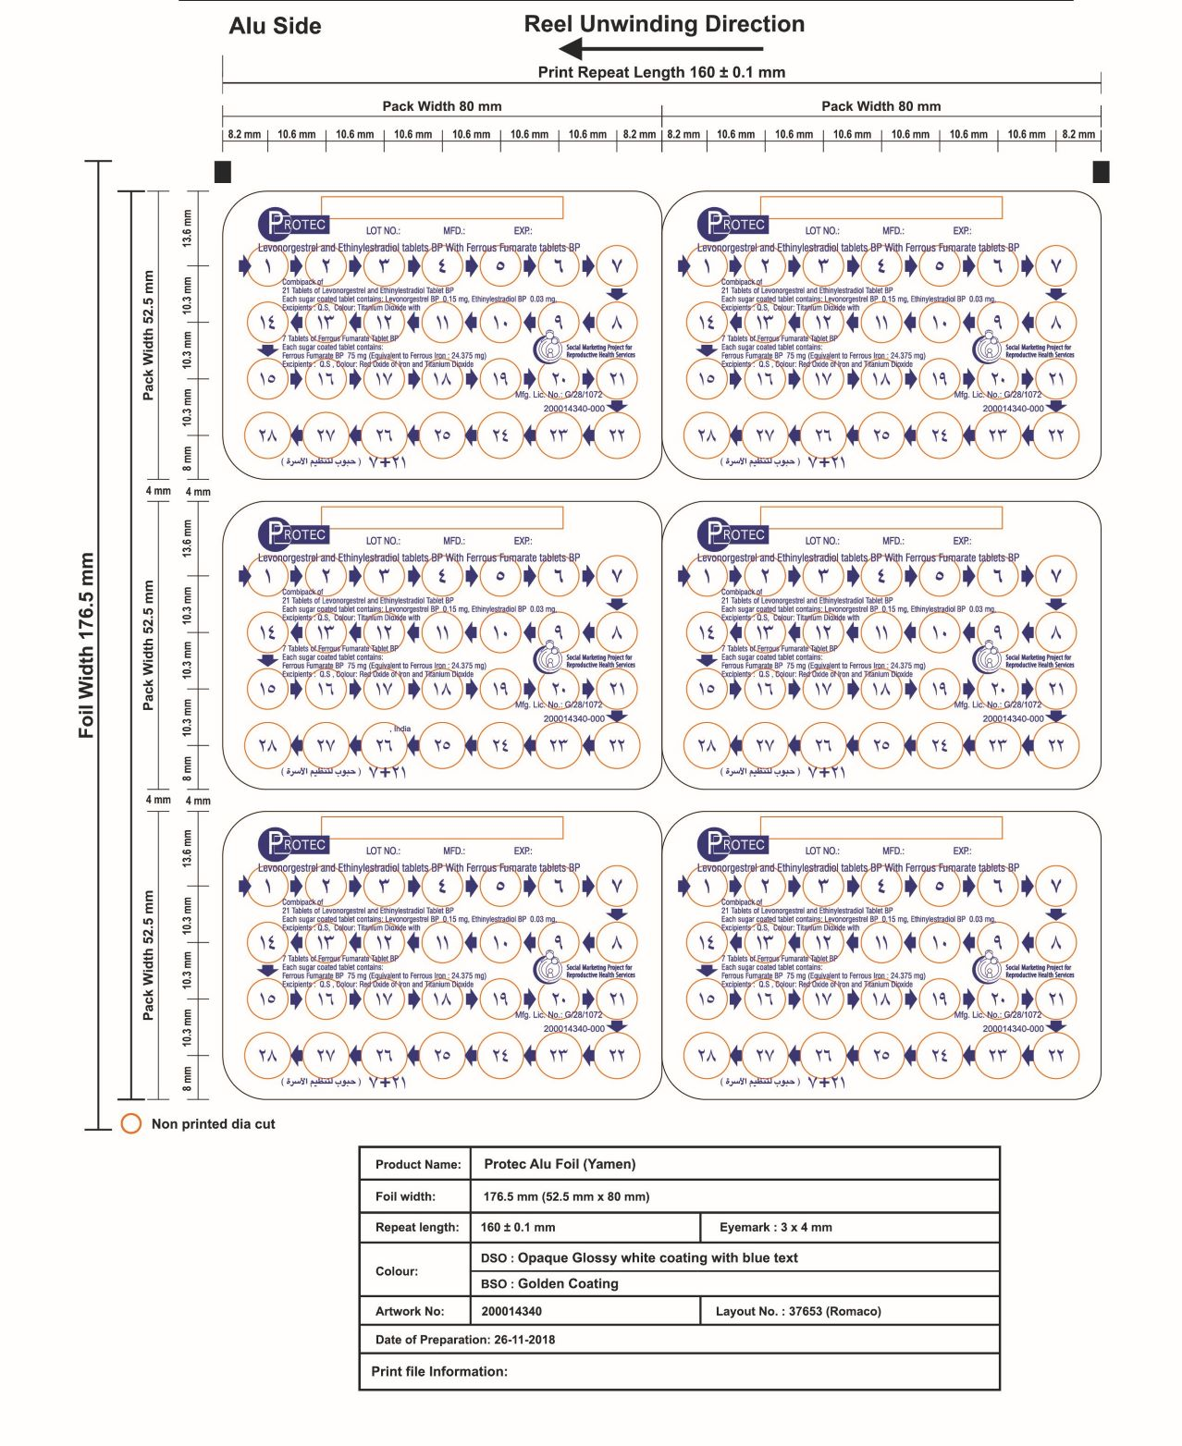
- Artwork Ref. no.1.a

- Artwork Ref. no.1.b
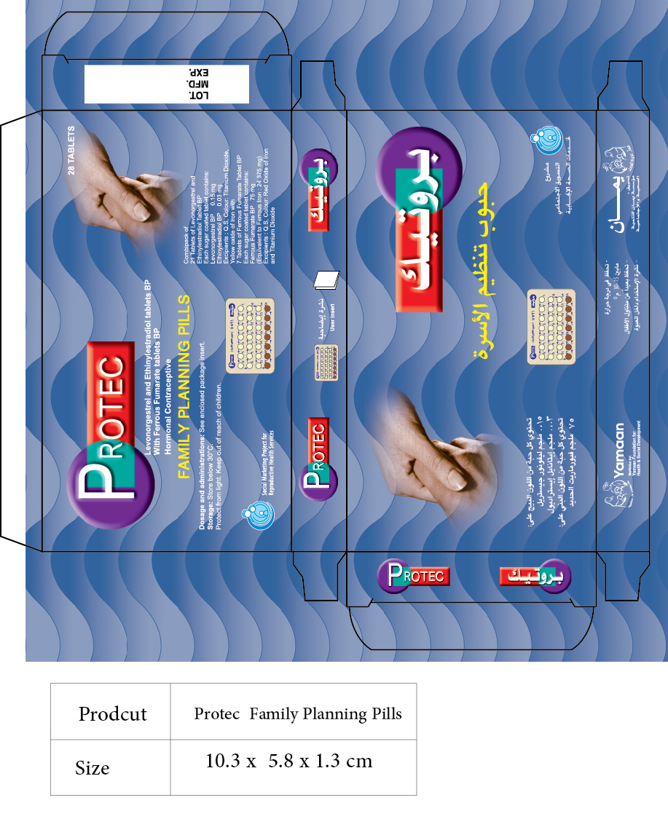

- Artwork Ref. no.1.c
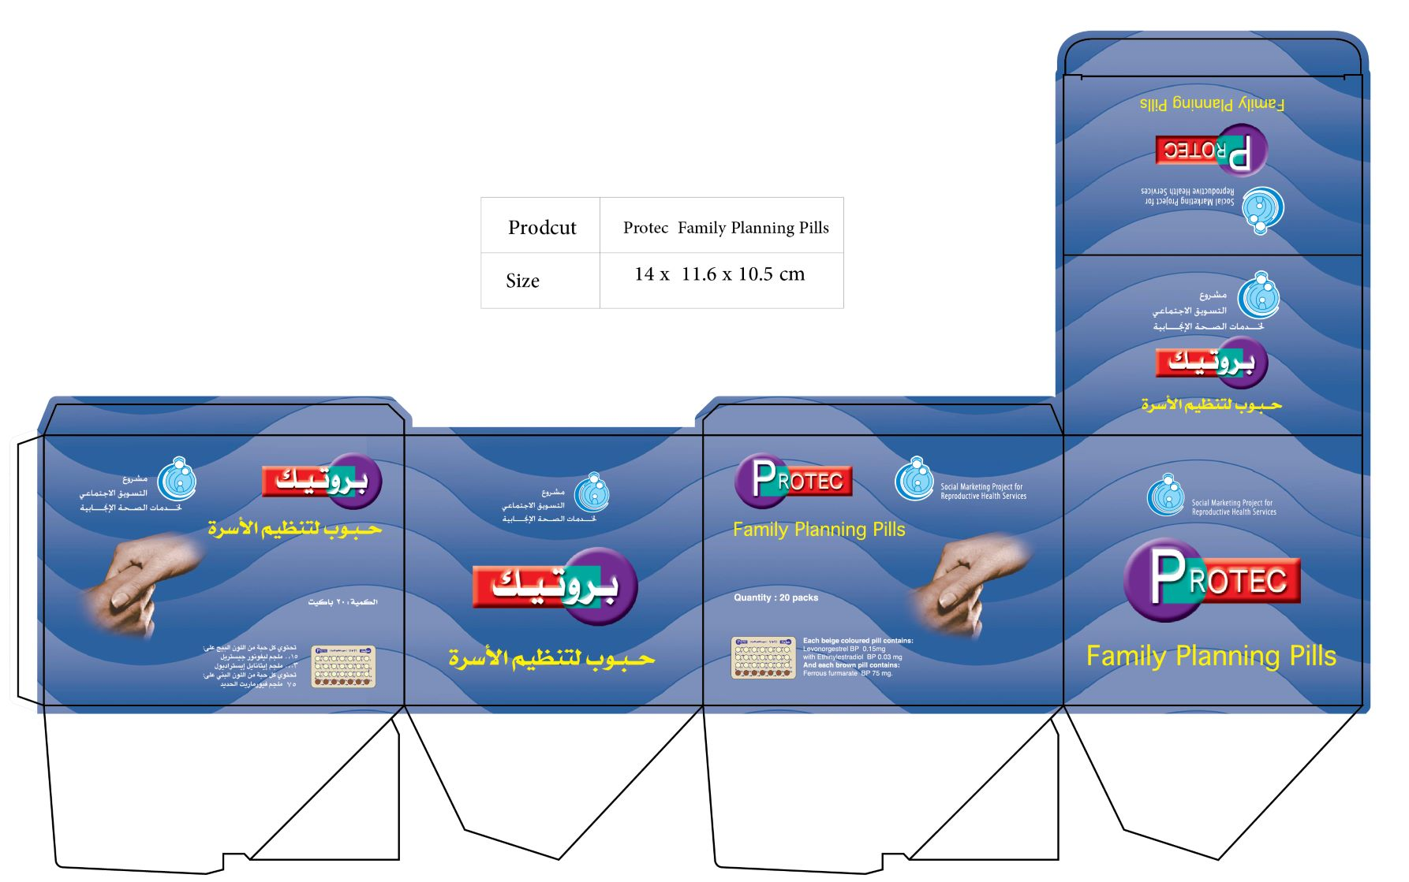
- Artwork Ref. no.1.d
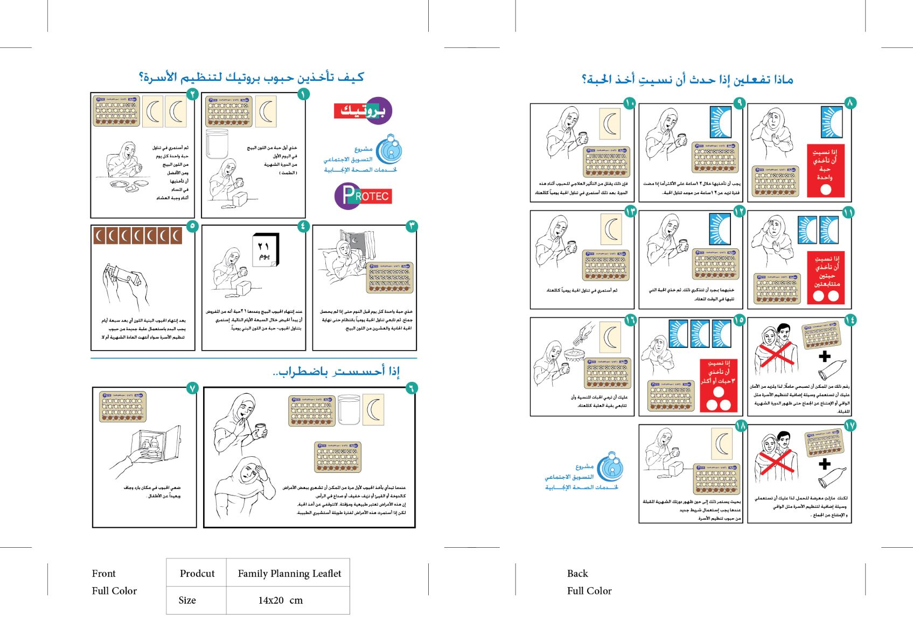

Lot No.2
- Artwork Ref. no.2.a
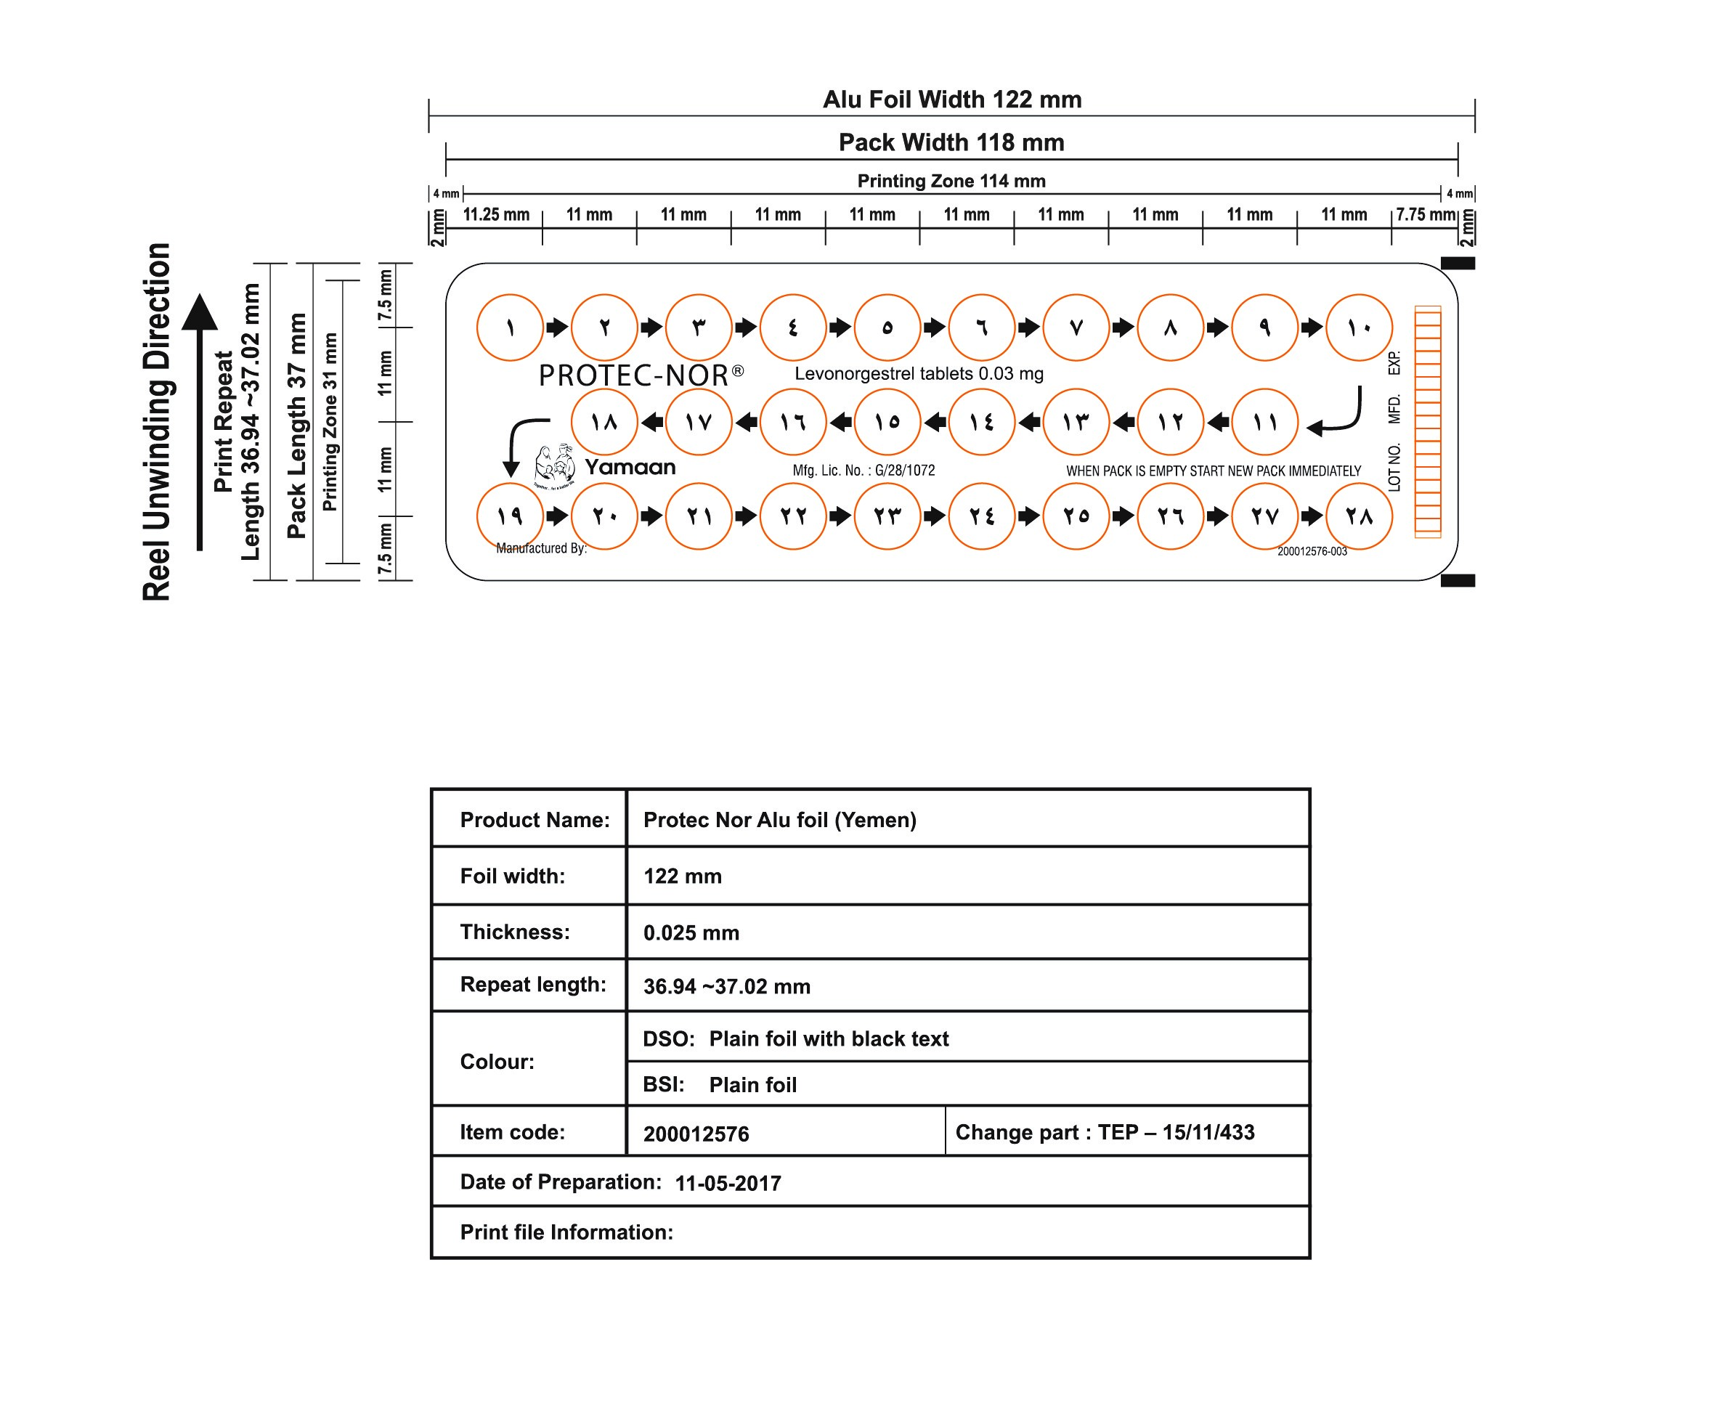

- Artwork Ref. no.2.b
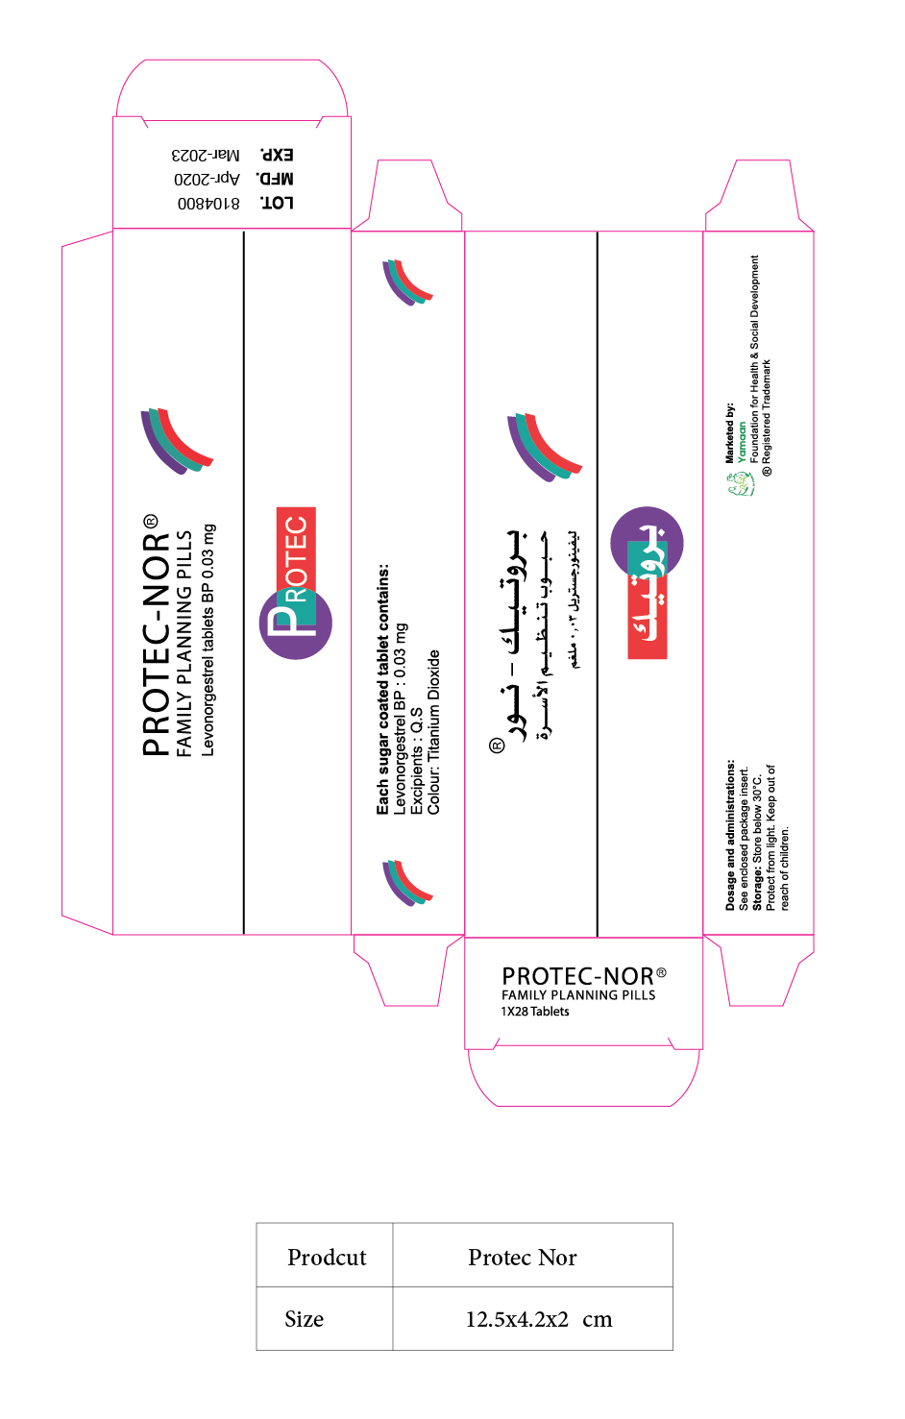

- Artwork Ref. no.2.c
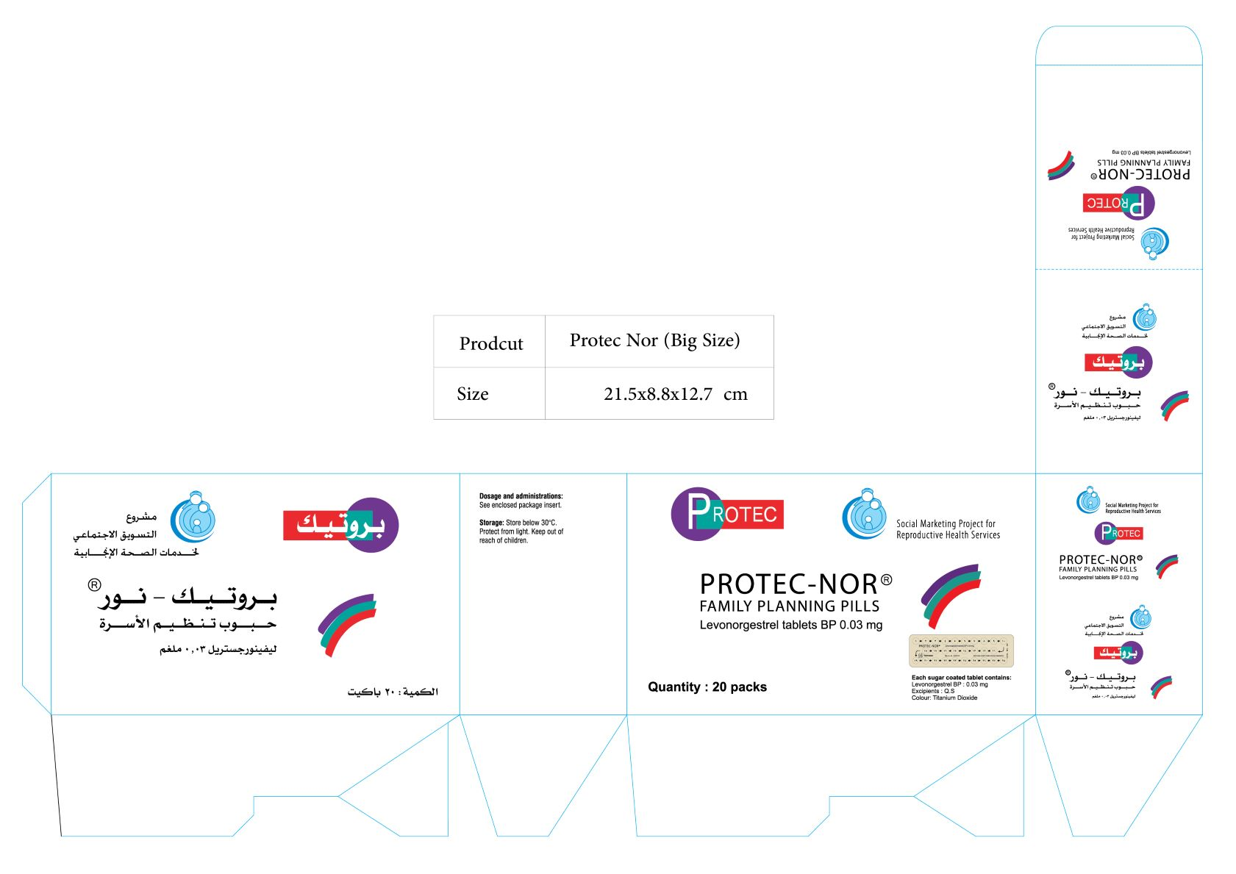

- Artwork Ref. no.2.d
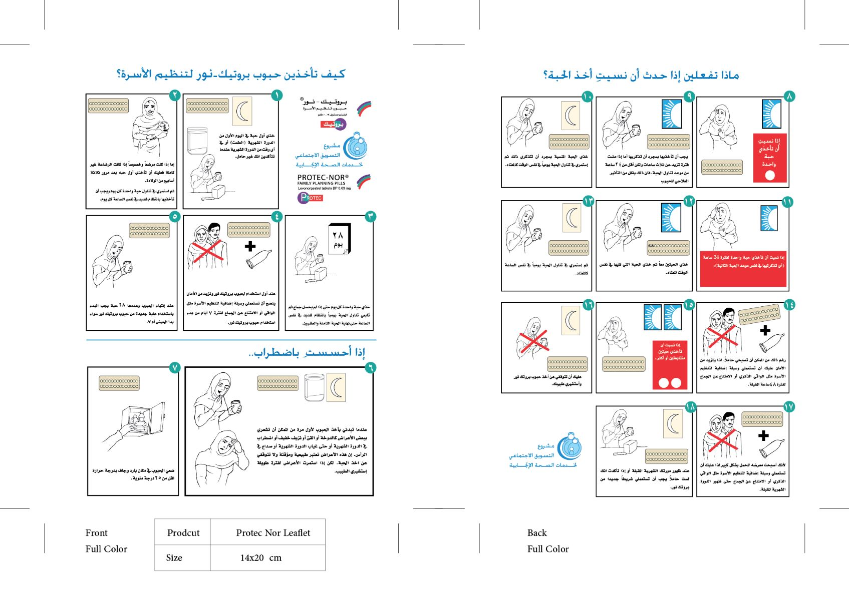

Lot No.3
- Artwork Ref. no.3.a
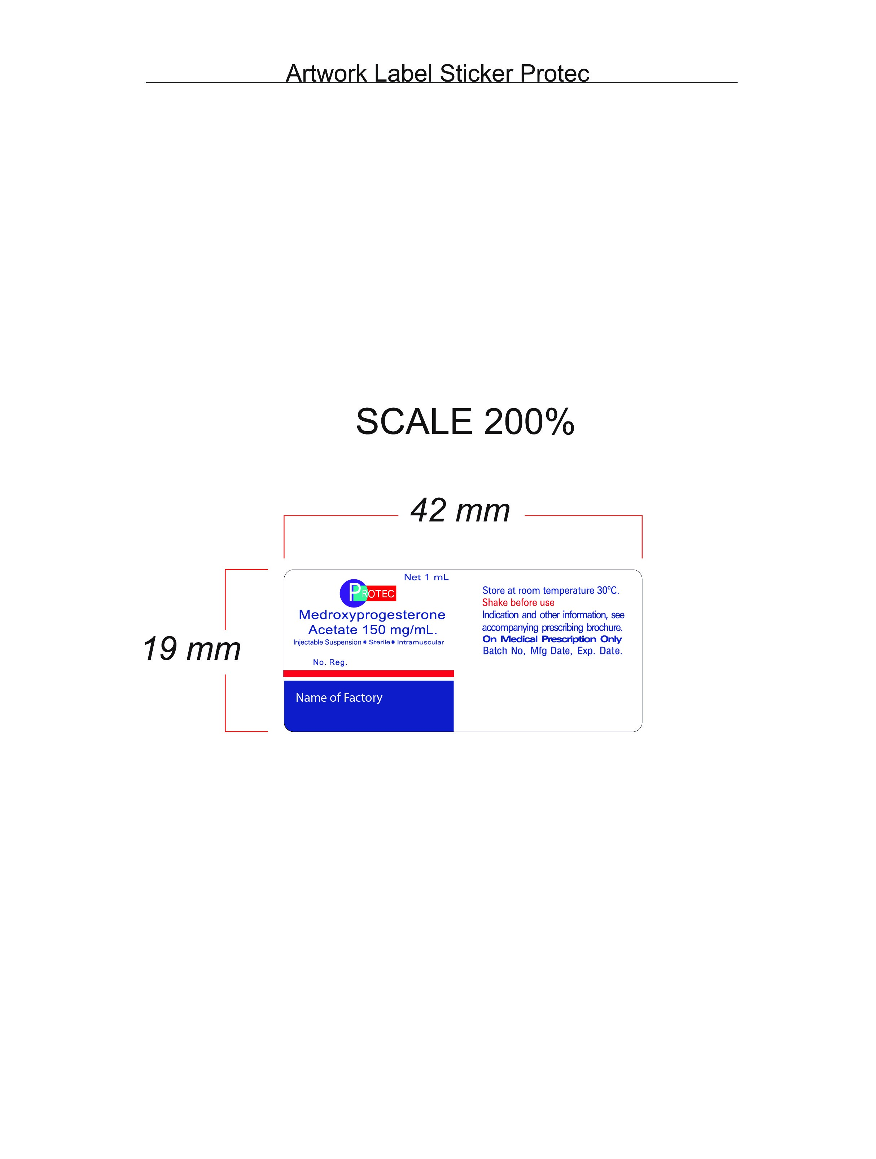

- Artwork Ref. no.3.b
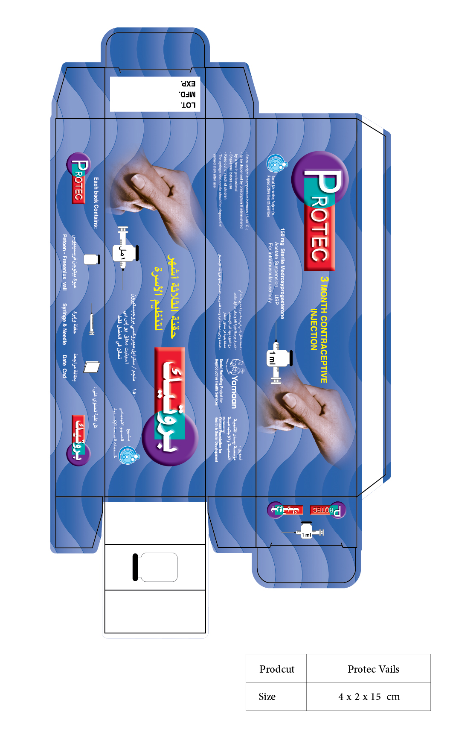

- Artwork Ref. no.3.c
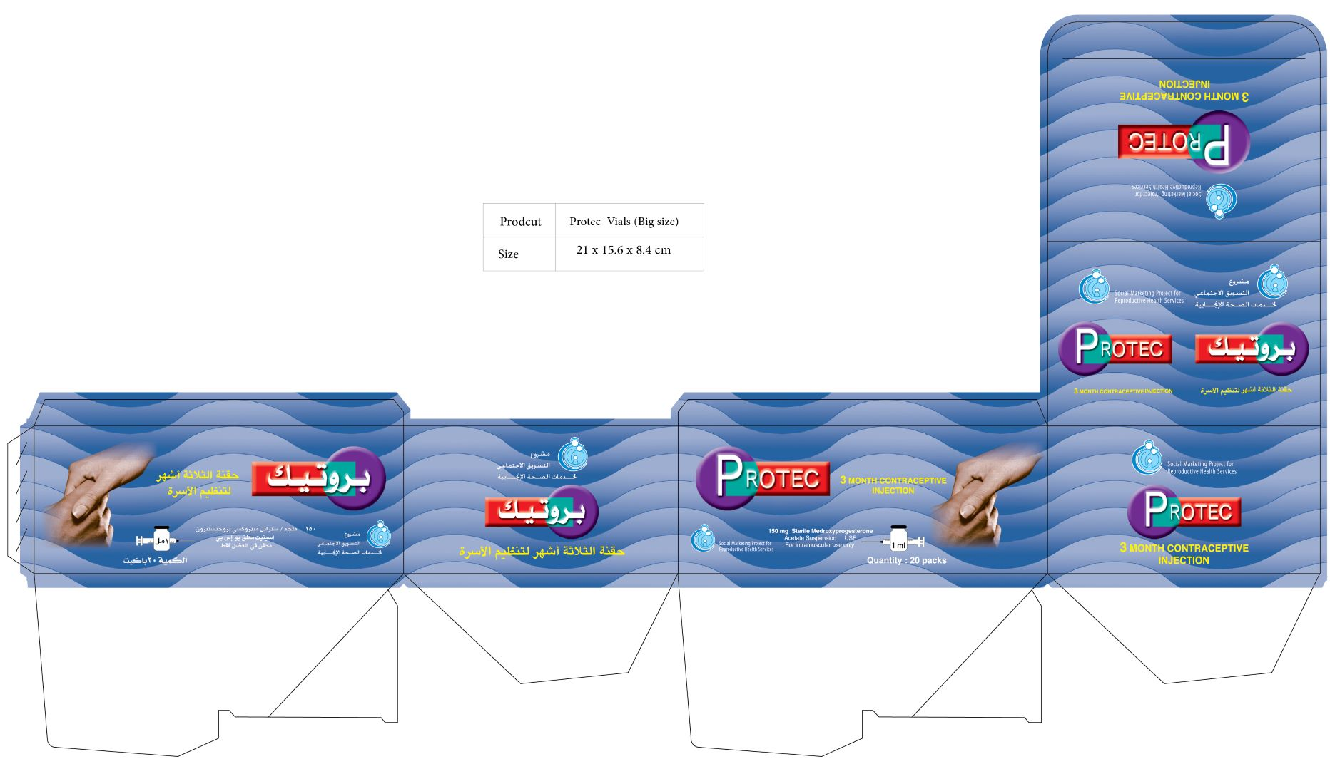

- Artwork Ref. no.3.d
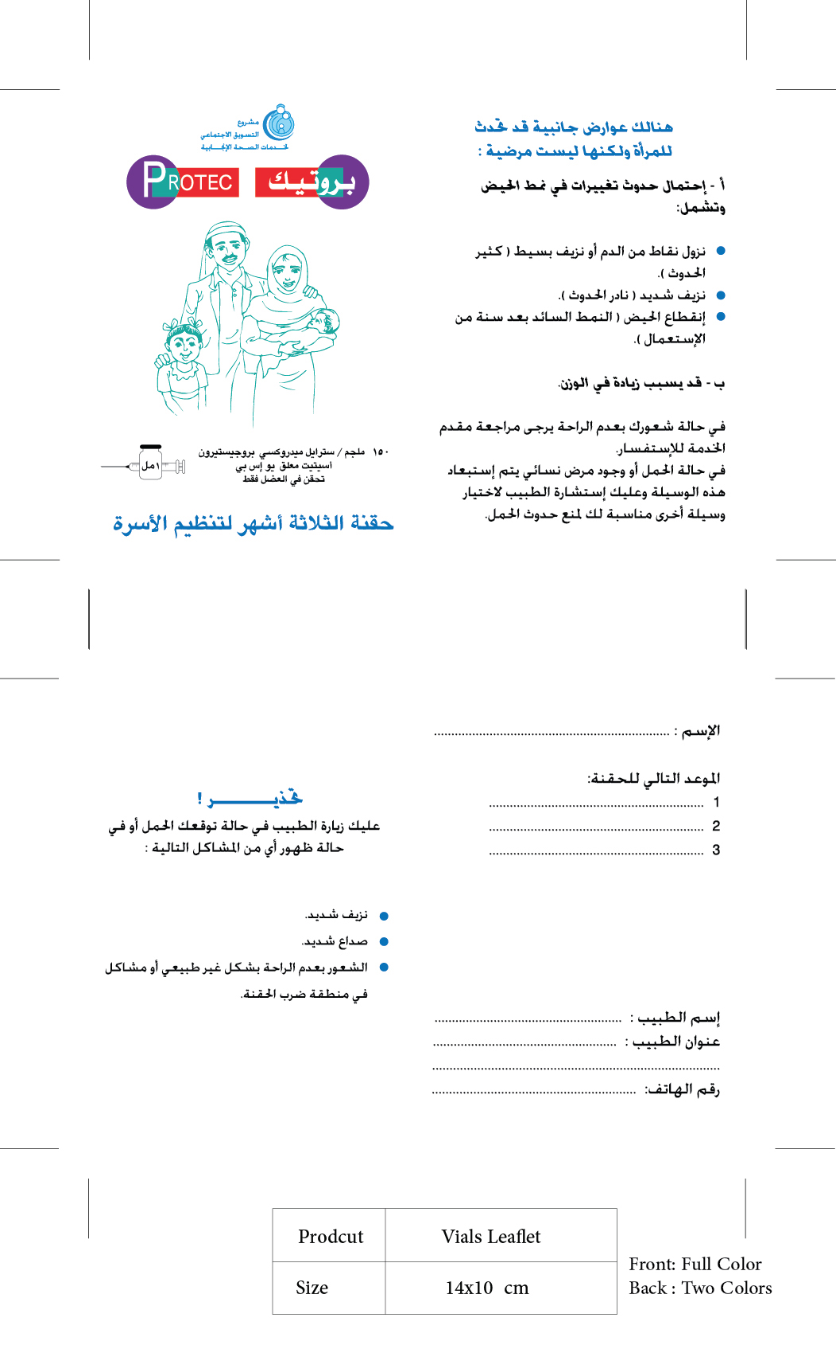
Lot No.4
- Artwork Ref. no.4.a
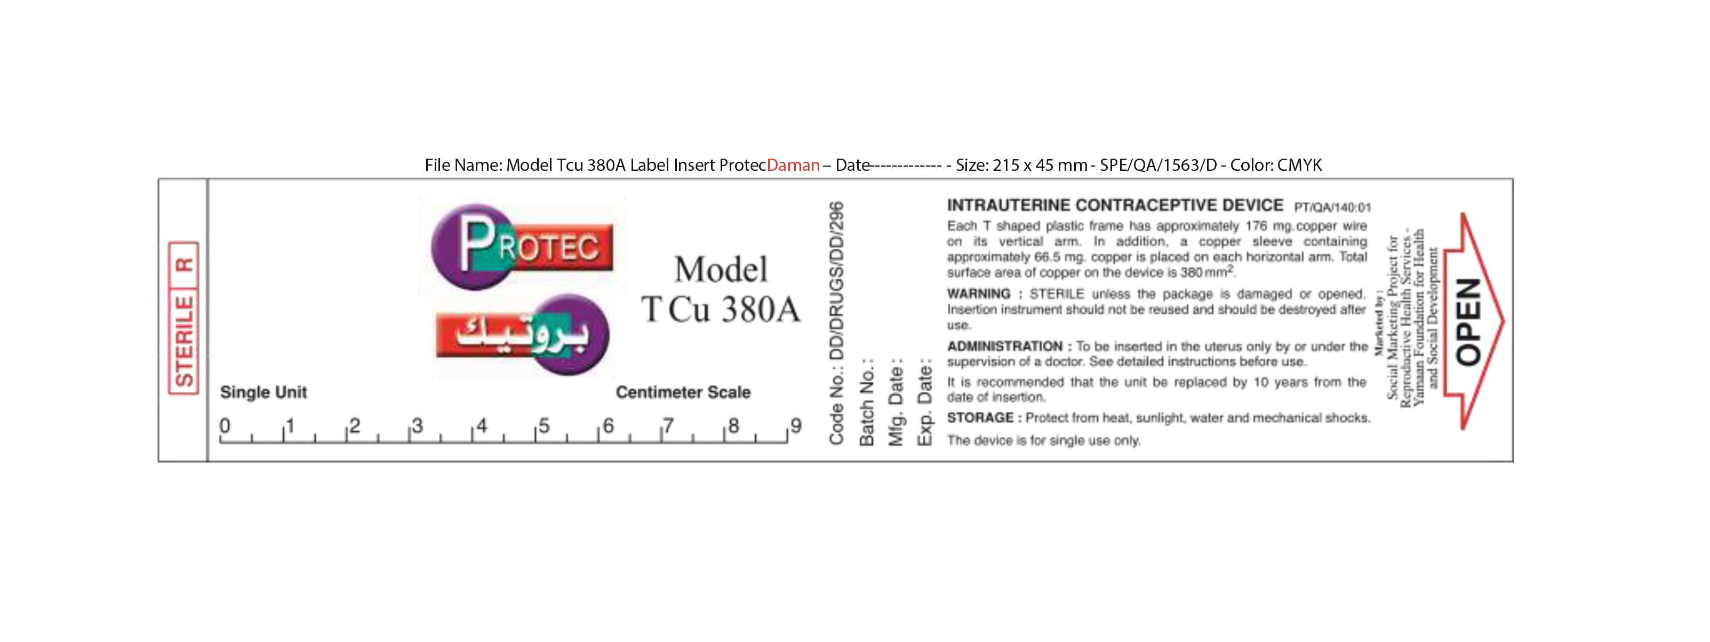

- Artwork Ref. no.4.b
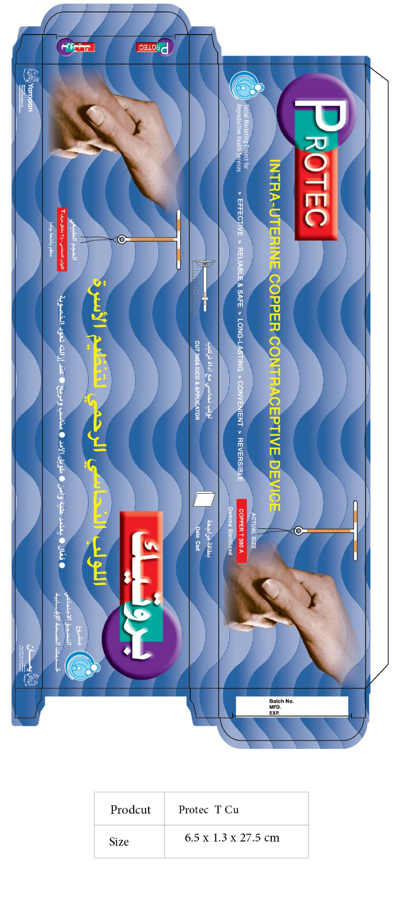

- Artwork Ref. no.4.c
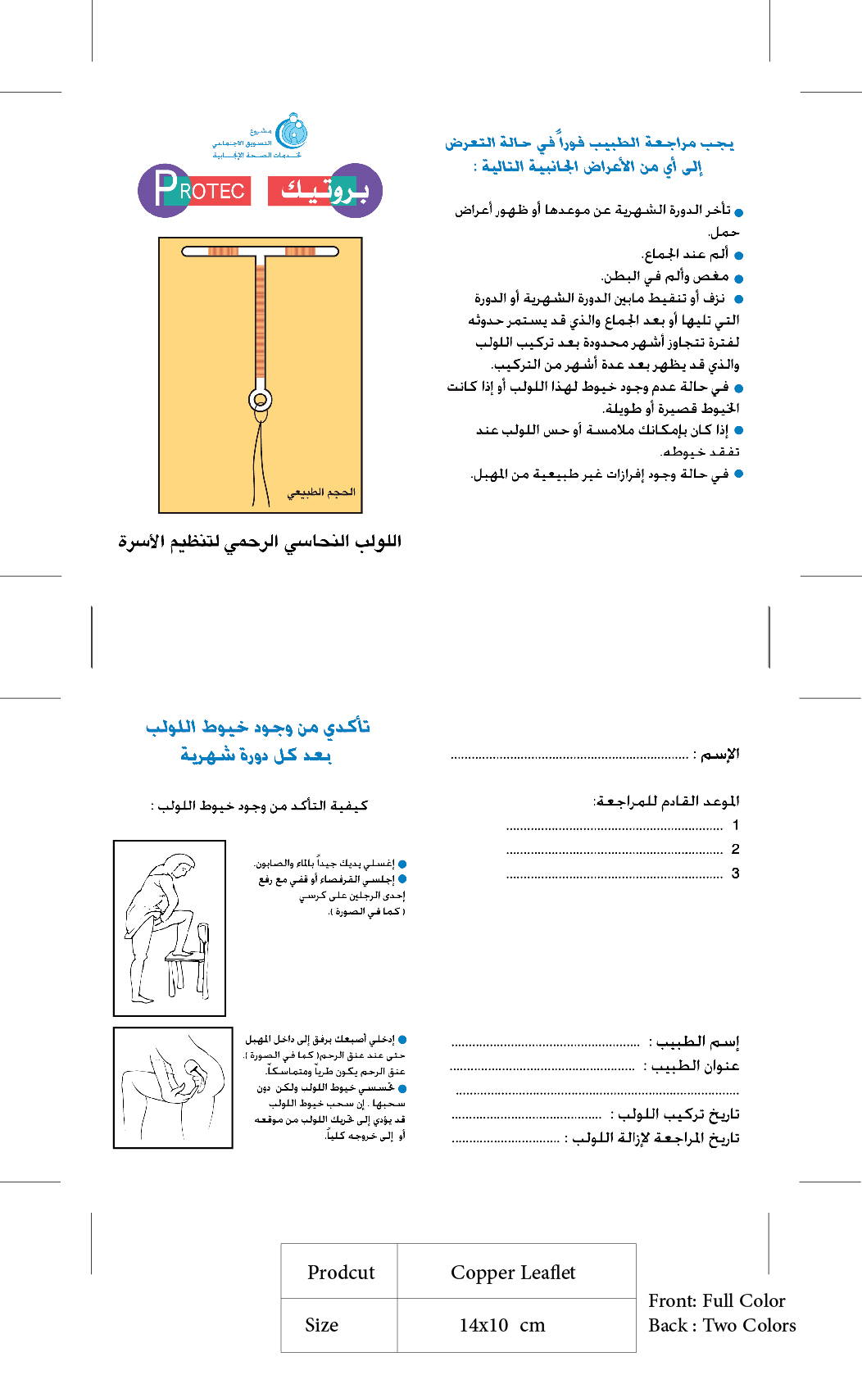

[Text in this Section shall not be modified.]
Bonds shall only be permitted with prior approval from KfW.
Non-performance shall include all terminations of contracts where (a) non-performance was not challenged by the supplier, including through referral to the dispute resolution mechanism under the respective contract, and (b) contracts that were so challenged but fully settled against the supplier. Non-performance shall not include contracts where Purchaser’s decision was overruled by the dispute resolution mechanism.
This requirement also applies to contracts executed by the Bidder as a JV member.
The similarity shall be based on the physical size, complexity, methods/technology and/or other characteristics described in Section VII, Schedule of Requirements. Summation of number of small value contracts (less than the value specified under requirement) to meet the overall requirement will not be accepted.
Substantial completion shall be based on 80% or more completed under the contract.
For contracts under which the Bidder participated as a joint venture member or sub-contractor, only the Bidder’s share, by value, shall be considered to meet this requirement.
In the case of JV, the value of contracts completed by its members shall not be aggregated to determine whether the requirement of the minimum value of a single contract has been met. Instead, each contract performed by each member shall satisfy the minimum value of a single contract as required for single entity. In determining whether the JV meets the requirement of total number of contracts, only the number of contracts completed by all members each of value equal or more than the minimum value required shall be aggregated.
Capitalised terms used, but not otherwise defined in this Declaration of Undertaking have the meaning given to such term in KfW’s “Guidelines for the Procurement of Consulting Services, Works, Plant, Goods and Non-Consulting Services in Financial Cooperation with Partner Countries”.
The PEA means the purchaser, the employer, the client, as the case may be, for the procurement of Consulting Services, Works, Plant, Goods or Non-Consulting Services.
In case ILO conventions have not been fully ratified or implemented in the Employer’s country the Applicant/Bidder/Contractor shall, to the satisfaction of the Employer and KfW, propose and implement appropriate measures in the spirit of the said ILO conventions with respect to a) workers grievances on working conditions and terms of employment, b) child labour, c) forced labour, d) worker’s organisations and e) non-discrimination.
In the case of a JV, insert the name of the JV. The person who will sign the application, bid or proposal on behalf of the Applicant/Bidder shall attach a power of attorney from the Applicant/Bidder.
[In circumstances where it is of utmost importance that Bidders have a longer company history, this requirement may be increased to up to five (5) years; if such a longer period is chosen, please amend the revised number of years throughout this table].
If the most recent set of financial statements is for a period earlier than 12 months from the date of bid, the reason for this should be justified.
See Section III, Qualification and Evaluation Criteria, Qualification, Sub-Factor 3.2
In case ILO conventions have not been fully ratified or implemented in the Employer’s country the Applicant/Bidder/Contractor shall, to the satisfaction of the Employer and KfW, propose and implement appropriate measures in the spirit of the said ILO conventions with respect to a) workers grievances on working conditions and terms of employment, b) child labour, c) forced labour, d) worker’s organisations and e) non-discrimination.
Only required to be filled in case of line items being listed; not required for lots.
Earliest delivery date is used in cases where the Purchaser cannot accept delivery before a specific date, e.g. if construction work is still under way; if there is no earliest delivery date required, leave this column blank.
Only use if quantity/physical unit can be clearly attributed.
Bidder’s shall provide a clause-by-clause commentary on the Purchaser’s Specifications, demonstrating the Goods’ and Services’ responsiveness to those Specifications or a statement of deviations and exceptions to the provisions of the Purchaser’s Specifications. General replies to the Purchaser’s Specifications, such as “acceptable”, “comply”, “yes”, etc., or simply copying the Purchaser’s specifications word-by-word, will be treated without exception as non-responsive during the technical evaluation; bidders are also requested to strictly refrain from self-classification of their replies to the Purchaser’s Specifications (such as “acceptable”, “better”, “compliant”, etc.); any statement made by the Bidder’s must be verifiable in the provided catalogues/leaflets (“custom-made” catalogues/leaflets, i.e. literature specifically manufactured for this tender, and only consisting of a picture and some text, and generally appearing unprofessional, will not be accepted).

